

**On Approval of the Rules for registration, accounting and issuance of permits for aerial surveys**

***Unofficial translation***

Decree of the Government of the Republic of Kazakhstan dated June 4, 2003 N 530.

      Unofficial translation

      Footnote. Heading as amended by the Decree of the Government of the Republic of Kazakhstan dated 19.01.2012 No. 126 (shall be enforced from 30.01.2012).   
      Footnote. It became invalid by the Decree of the Government of the Republic of Kazakhstan dated 18.03.2022 No. 141 (effective after ten calendar days after the date of its first official publication).

      In order to implement the Law of the Republic of Kazakhstan dated July 3, 2002 "On Geodesy and Cartography", the Government of the Republic of Kazakhstan decides to:

      1. Approve the attached Rules for registration, accounting and issuance of permits for aerial surveys.

      Footnote. Paragraph 1 as amended by the Decree of the Government of the Republic of Kazakhstan dated 19.01.2012 No. 126 (shall be enforced from 30.01.2012).

      2. This decree comes into force from the date of signing.

|  |
| --- |
| *Prime-Minister of the*  *Republic of Kazakhstan* |

|  |  |
| --- | --- |
|  | Approved  by the decree of the Government  of the Republic of Kazakhstan  dated June 4, 2003 № 530 |

**The Rules for registration, accounting and issuance of permits for aerial surveys**

      Footnote. The Rules as amended by the Decree of the Government of the Republic of Kazakhstan dated 08.04.2020 No. 185 (shall be enforced twenty-one calendar days after the day of its first official publication).

**Chapter 1. General provisions**

      1. These Rules are developed in accordance with subparagraph 8) of Article 6 of the Law of the Republic of Kazakhstan dated July 3, 2002 "On Geodesy and Cartography" and determine the procedure for registration, accounting and issuance of permits for aerial surveys.

      2. Registration, accounting and issuance of permits for aerial surveys performed using photographic, television, infrared, radar and other equipment for activities of state, special and (or) industry purposes, are carried out by the authorized body in the field of geodesy and cartography (hereinafter - the authorized body).

      Registration, accounting and issuance of permits for aerial surveys are carried out in order to ensure the defense and national security of the Republic of Kazakhstan during aerial surveys.

      3. The following concepts are used in these Rules:

      1) aerial photography - surveying the terrain from aerial devices using surveying systems (information receivers) operating in different parts of the spectrum of electromagnetic waves;

      2) aerial photography surveys - work consisting of flight survey work and data processing.

**Chapter 2. Procedure for registration, accounting and issuance of a permit for aerial surveys**

      4. In order to obtain a permit to conduct aerial surveys (hereinafter referred to as the permit), individuals and legal entities (hereinafter referred to as the applicants) submit an application to the authorized body for the conduct of aerial photography surveys, in accordance with Appendix 1 to these Rules, with electronic copies of documents attached (hereinafter referred to as documents) specified in paragraph 5 of these Rules, through the web portal of "electronic government" www.egov.kz.

      The permit is issued by the authorized body no later than thirteen working days from the date of receipt of the documents.

      5. List of documents required for issuing a permit:

      1) an application for aerial surveys in the form of an electronic document certified by the electronic digital signature of the applicant, in accordance with Appendix 1 to these Rules;

      2) electronic copies of documents confirming the right of ownership or a lease agreement for an aircraft or an agreement for provision of services with an owner who has an aircraft for aerial survey;

      3) an electronic copy of the cartogram of the territory where aerial surveys are planned, indicating its geographical coordinates;

      4) electronic copies of technical projects (or terms of reference) for the planned aerial surveys.

      The authorized body, within two working days from the date of receipt of the applicant's documents, checks the completeness of the submitted documents.

      If the applicant submits an incomplete package of documents, the authorized body within the specified time limits gives a reasoned refusal to further consider the application.

      6. In case of detection of duplication of the claimed works financed from the state budget, to the previously conducted aerial surveys (hereinafter referred to as duplication), the authorized body within two working days from the date of receipt of the applicant's documents notifies him of this. In this case, the applicant for aerial surveys uses previously created aerial survey materials and data.

      7. In cases of completeness of the submitted documents specified in paragraph 5 of these Rules, and the absence of duplication, the authorized body, within two working days from the date of receipt of the applicant's documents, sends a request with the attached documents for approval of aerial surveys to the Ministry of Defense of the Republic of Kazakhstan, the National Security Committee of the Republic of Kazakhstan and the State Security Service of the Republic of Kazakhstan (hereinafter referred to as the state bodies).

      8. State bodies, having considered the submitted documents, within ten working days from the date of receipt of the documents, send positive or negative responses to the authorized body.

      If the state authorities fail to provide a response within the established timeframe, the issuance of a permit is considered agreed.

      9. The authorized body, within one working day from the date of receipt of positive responses from state bodies, issues a permit in the form, in accordance with Appendix 2 to these Rules, valid until the end of the current year.

      On the grounds provided for in Article 19-1 of the Law of the Republic of Kazakhstan dated April 15, 2013 "On Public Services", the authorized body within the specified time limits prepares and sends to the applicant a reasoned refusal to issue a permit in the form in accordance with Appendix 3 to these Rules.

      10. Upon completion of the work, the applicant submits free of charge one copy of copies of the aerial survey, geodetic and cartographic materials and data created by him to the National Cartographic and Geodetic Fund of the Republic of Kazakhstan with preservation of copyright.

      11. Registration and accounting of issued permits are maintained in the state information system of permits and notifications.

**Chapter 3. Final provisions**

      12. In case of disagreement with the actions of the authorized body, the applicant may appeal against the decision of the authorized body in the manner prescribed by law.

|  |  |
| --- | --- |
|  | Appendix 1 to the Rules for registration,  accounting and issuance of permits  for aerial surveys |
|  | Form |

|  |  |  |
| --- | --- | --- |
| [Name of the authorized body, details  (in the state language)] |  | [Name of the authorized body, details  (in the Russian language)] |

      No _________ "___" ______20___

**Application for aerial surveys**

      I ask you to issue permission to conduct aerial survey. Territorial placement of aerial photography objects

            ____________________________________________________________________

            ____________________________________________________________________

            the area of aerial photography survey ____________________________ (square kilometers)

            purpose of aerial photography survey ___________________________________________

            aerial photography specifications ______________________________________________

            conditions and time of aerial photography survey _________________________________

            I agree to the use of information constituting a secret protected by law contained in information systems.       [Date of creation] [Last name, first name, patronymic (if any) of the signer]

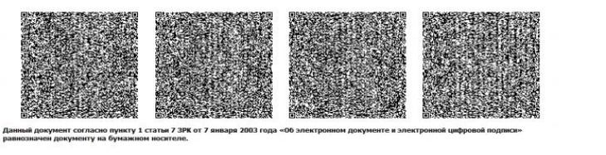

|  |  |
| --- | --- |
|  | Appendix 2 to the Rules for registration,  accounting and issuance of permits  for aerial surveys |
|  | Form |

|  |  |  |
| --- | --- | --- |
| [Name of the authorized body, details  (in the state language)] |  | [Name of the authorized body, details  (in the Russian language)] |

**Permission for conduct of aerial surveys**

      No _________ "___" ______20___

            Surname, name, patronymic (if any) of an individual or full name of the legal entity

      ______________________________________

      Type and purpose of work ______________________________________________

      Location of work site _______________________________________

      The following works declared for production are allowed:

|  |  |  |  |  |  |
| --- | --- | --- | --- | --- | --- |
| № | Name of requested works | Amount of work | | Amount of work | |
| Declared | Unit of measurement  (square kilometers) | Permitted | Unit of measurement  (square kilometers) |
| 1 | 2 | 3 | 4 | 5 | 6 |
|  |  |  |  |  |  |

                                                      Valid until: "_____"

                                                      _______20___

      [Position of the signer]                   [Last name, first name, patronymic (if any) of the signer]

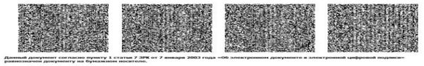

|  |  |
| --- | --- |
|  | Appendix 3 to the Rules for registration,  accounting and issuance of permits  for aerial surveys |
|  | Form |

|  |  |  |
| --- | --- | --- |
| [Name of the authorized body, details  (in the state language)] |  | [Name of the authorized body, details  (in the Russian language)] |

                                          Last name, first name, patronymic (if any) of

                                          an individual or a full name of a legal entity

                                          ____________________________

**Reasoned refusal**

      No _________                   "___" ______20___

            The authorized body for geodesy and cartography, having considered your application No.

      _________ dated "___" _____ 20__, refuses to issue permission to conduct aerial surveys for the following reason:

            [the reason of the reasoned refusal]

            [Position of the signer]                   [Surname, name, patronymic (if any) of the signer]

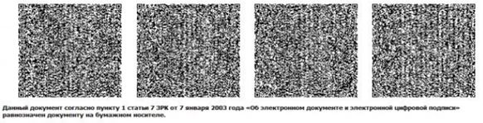

© 2012. «Institute of legislation and legal information of the Republic of Kazakhstan» of the Ministry of Justice of the Republic of Kazakhstan