

**On approval of the Pension Rules for the single accumulative pension fund**

***Invalidated***
***Unofficial translation***

Resolution N 984 of the Government of the Republic of Kazakhstan dated September 18, 2013. Abolished by the Decree of the Government of the Republic of Kazakhstan dated 30.06.2023 No. 528

*Unofficial translation*

      Footnote. Abolished by the Decree of the Government of the Republic of Kazakhstan dated 30.06.2023 No. 528 (effective from 07/01/2023).

      In accordance with paragraph 1 of Article 37 , of the Law of the Republic of Kazakhstan dated June 21, 2013 “ On Provision of Pension in the Republic of Kazakhstan” the Government of the Republic of Kazakhstan **hereby RESOLVED as follows**:

      1. To approve the attached Pension Rules of the single accumulative pension fund (hereinafter referred to as the Rules).

      2. This resolution shall be enforced upon expiry of ten calendar days after the date of its first official publication, with the exception of section 3 of the Rules, which shall be enforced from January 1, 2014.

|  |  |
| --- | --- |
| *Prime Minister of the Republic of Kazakhstan* | *S.Akhmetov* |

|  |  |
| --- | --- |
|  | Approved by |
|  | Resolution N 984 |
|  | of the Government |
|  | of the Republic of Kazakhstan |
|  | dated September 18, 2013 |

**Pension rules of the single accumulative pension fund**

      Footnote. Rules are in the wording of the resolution of the Government of the RK dated 28.10.2015 No. 846 (shall be enforced from 01.01.2016).

**Chapter 1. General provisions**

      Footnote. Title of chapter 1 is in the wording of the resolution of the Government of the Republic of Kazakhstan dated 08.05.2019 № 263 (shall be enforced upon expiry of ten calendar days after its first official publication).

      1. These Pension Rules of the single accumulative pension fund (hereinafter referred to as the Rules) shall be developed in accordance with the Law of the Republic of Kazakhstan dated June 21, 2013 "On Provision of Pensions in the Republic of Kazakhstan" (hereinafter referred to as the Law) and shall establish peculiarities of legal relations between the single accumulative pension fund (hereinafter referred to as the SAPF) and:

      1) the depositor of mandatory pension contributions;

      2) an individual for whom mandatory professional pension contributions shall be transferred;

      3) the recipient of pension payments at the expense of mandatory pension contributions and (or) mandatory professional pension contributions (hereinafter referred to as the recipient of pension payments);

      4) agent for payment of mandatory professional pension contributions.

      2. mandatory pension contributions shall be payable at rates determined by Law:

      agents for the payment of mandatory pension contributions;

      agents for payment of mandatory professional pension contributions (hereinafter referred to as - agent).

      3. Mandatory pension contributions and mandatory professional pension contributions shall be paid in the national currency of the Republic of Kazakhstan. Mandatory pension contributions cannot be paid to others.

      4. The procedure and terms of calculation, retention (accrual) and transfer of mandatory pension contributions and mandatory professional pension contributions and recovery thereof, as well as payment of pension payments from mandatory pension contributions and mandatory professional pension contributions from the SAPF shall be established by the Government of the Republic of Kazakhstan and the Law.

**Chapter 2. Procedure for concluding the agreement on provision of pensions at the expense of mandatory pension contributions**

      Footnote. Title of chapter 2 is in the wording of the resolution of the Government of the Republic of Kazakhstan dated 08.05.2019 № 263 (shall be enforced upon expiry of ten calendar days after its first official publication).

      5. SAPF shall attract mandatory pension contributions and shall pay pension savings from mandatory pension contributions.

      6. The agreement on provision of pensions at the expense of mandatory pension contributions shall be an accession agreement, the terms of which shall be approved by the SAPF and posted on the SAPF website.

      The       agreement on provision of pensions at the expense of mandatory pension contributions shall establish the rights, obligations and liabilities provided for by the Law, as well as other peculiarities of legal relations between the SAPF, the depositor of mandatory pension contributions (the recipient of pension payments at the expense of mandatory pension contributions).

      7. As excluded by the resolution of the Government of the Republic of Kazakhstan dated 08.05.2019 No. 263 (shall be enforced upon expiry of ten calendar days after its first official publication).

      7-1. Mandatory pension contributions shall be credited to open individual pension accounts of depositors of mandatory pension contributions. If an individual shall not have an open individual pension account in the SAPF to account for mandatory pension contributions, the individual pension account shall be opened on the basis of lists of individuals received from the State Corporation "Government for Citizens" (hereinafter referred to as the State Corporation) for which mandatory pension contributions shall be transferred in accordance with the procedure determined by the Government of the Republic of Kazakhstan.

      At the same time, information on the bank details of the current identity document issued by the authorized body of the Republic of Kazakhstan, on its registration at the place of residence in the Republic of Kazakhstan, SAPF shall receive from the relevant state information systems.

      Footnote. The Rules as amended by paragraph 7-1 in accordance with the resolution of the Government of the Republic of Kazakhstan dated 08.05.2019 № 263 (shall be enforced upon expiry of ten calendar days after its first official publication).

      8. The depositor shall be considered to have acceded to the agreement on provision of pensions at the expense of the mandatory pension contributions, mandatory professional pension contributions from the date of receipt by the single accumulative pension fund of the electronic notification of the State Corporation of the entry of information on the agreement on provision of pensions at the expense of mandatory pension contributions, Mandatory professional pension contributions to a single list of individuals who have concluded the agreement on provision of pensions at the expense of mandatory pension contributions, mandatory professional pension contributions. (hereinafter referred to as the single list).

      Footnote. Paradraph 8 is in the wording of the resolution of the Government of the Republic of Kazakhstan dated 08.05.2019 № 263 (shall be enforced upon expiry of ten calendar days after its first official publication).

**Chapter 3. Procedure for concluding the agreement on provision of pensions at the expense of the mandatory professional pension contributions**

      Footnote. Title of chapter 3 in the wording of the resolution of the Government of the Republic of Kazakhstan dated 08.05.2019 № 263 (shall be enforced upon expiry of ten calendar days after its first official publication).

      9. SAPF shall attract mandatory professional pension contributions and shall pay pension savings at the expense of mandatory professional pension contributions.

      10. The agreement on provision of pensions at the expense of the mandatory professional pension contributions shall be an accession agreement, the terms of which shall be approved by the SAPF and posted on the SAPF website.

      The agreement on provision of pensions at the expense of the mandatory professional pension contributions shall establish the rights, obligations and responsibilities provided for by the Law, as well as other peculiarities of legal relations between SAPF, an individual for whom mandatory professional pension contributions shall be transferred (the recipient of pension payments at the expense of mandatory professional pension contributions), and an agent.

      11. The conclusion of the agreement on provision of pensions at the expense of the mandatory professional pension contributions (accession agreement) shall be carried out by signing by an agent and an individual, for whom mandatory professional pension contributions shall be transferred, an application for the opening of an individual pension account for the accounting of mandatory professional pension contributions in the form approved by the internal document of the SAPF, which shall be posted on the website of the SAPF.

      Footnote. Paragraph 11 in the wording of the resolution of the Government of the Republic of Kazakhstan dated 14.04.2016 № 215.

      12. The agent and an individual for whom compulsory professional pension contributions shall be transferred shall be considered to have acceded to the agreement on provision of pensions at the expense of the mandatory professional pension contributions from the date of receipt by SAPF of electronic notification from the State Corporation on entry of information on the agreement on provision of pensions at the expense of the mandatory professional pension contributions into a single list.

      Footnote. Paragraph 12 in the wording of the resolution of the Government of the Republic of Kazakhstan dated 14.04.2016 № 215.

      13. Upon availability of an earlier agreement on provision of pensions at the expense of the mandatory professional pension contributions, an individual, for whom mandatory professional pension contributions shall be transferred, and the new agent shall sign an application for accession to the agreement on provision of pensions at the expense of the mandatory professional pension contributions in the form, which shall be determined by internal documents of SAPF, without opening a new individual pension account for accounting for mandatory professional pension contributions.

      Mandatory professional pension contributions, investment income, penalties and other income in accordance with the legislation of the Republic of Kazakhstan on pension provision, received within the framework of the application specified in part one of paragraph 13 of these Rules, shall be recorded in the previously opened individual pension account for the accounting of mandatory professional pension contributions.

**Chapter 4. Procedure for informing the depositor of mandatory pension contributions, the individual for whom mandatory Professional pension contributions shall be transferred, or the recipient of pension payments on the state of pension savings**

      Footnote. Title of chapter 4 in the wording of the resolution of the Government of the Republic of Kazakhstan dated 08.05.2019 № 263 (shall be enforced upon expiry of ten calendar days after its first official publication).

      14. Information on the state of pension savings due to mandatory pension contributions and (or) mandatory professional pension contributions as of any date requested by the depositor of mandatory pension contributions, an individual for whom mandatory professional pension contributions shall be transferred, or the recipient of pension payments shall be provided to the SAPF from the date of opening of the individual pension account for accounting for mandatory pension contributions and (or) mandatory professional pension contributions to the SAPF.

      15. Provision of SAPF to the depositor of mandatory pension contributions, to the individual for whom mandatory professional pension contributions shall be transferred, or to the recipient of pension payments of information on the state of pension savings shall be carried out without charge.

      16. Information on the state of pension savings from mandatory pension contributions and (or) mandatory professional pension contributions, including in the framework of annual information, provided by SAPF to the depositor of mandatory pension contributions, to the individual for whom mandatory professional pension contributions shall be transferred, or to the recipient of pension payments, shall include information on:

      1) the amount of pension savings at the beginning and end of the requested period;

      2) the amount of accrued investment income at the beginning and end of the requested period;

      3) the commission from investment income and pension assets approved by the Board of the National Bank of the Republic of Kazakhstan and valid at the end of the requested period;

      4) the amount of pension contributions, penalties, transfers, payments of pension savings and (or) withheld individual income tax with indication of dates during the requested period;

      5) the amount of other transactions that affect the individual pension account for mandatory pension contributions or compulsory professional pension contributions, with indication of dates during the requested period.

      17. Information shall be provided by SAPF in one of the following ways, chosen by the depositor of mandatory pension contributions, by the individual for whom mandatory professional pension contributions shall be transferred, or by the recipient of pension payments:

      1) electronic:

      by e-mail to the address provided in the SAPF;

      by means of a personal cabinet using an electronic digital signature or user login and password;

      2) in case of personal application of the depositor of mandatory pension contributions, the individual for whom mandatory professional pension contributions shall be transferred, or the recipient of pension payments directly to the SAPF;

      3) by means of postal communication services.

      In case the depositor of mandatory pension contributions shall not choose a method of informing about the state of pension savings, the information shall be carried out by SAPF in case of personal application.

      Footnote. Paragraph 17 is in the wording of the resolution of the Government of the Republic of Kazakhstan dated 08.05.2019 № 263 (shall be enforced upon expiry of ten calendar days after its first official publication).

      17-1. When an individual pension account shall be opened in SAPF to account for mandatory pension contributions in accordance with paragraph 7-1 of these Rules, the method of providing SAPF with information on the state of pension savings due to mandatory pension contributions shall be automatically defined as "in case of personal application to SAPF," which the depositor of mandatory pension contributions shall have the right to change in accordance with part two of paragraph 19 of these Rules.

      Footnote. Paragraph 17-1 in accordance with the resolution of the Government of the Republic of Kazakhstan dated 08.05.2019 № 263 (shall be enforced upon expiry of ten calendar days after its first official publication).

      18. Information on the state of pension savings, including annual mandatory information for the past year, a contributor of mandatory pension contributions or a recipient of pension payments from mandatory pension contributions under agreements on provision of pensions at the expense of from mandatory pension contributions, concluded before approval of these resolutions, shall be carried out by SAPF in the manner specified in electronic formats, transferred to SAPF in accordance with the procedure established by the regulatory legal act of the authorized body, which shall carry out state regulation, control and supervision of the financial market and financial organizations, except for information through a payment card.

      Footnote. Paragraph 18 is in the wording of the resolution of the Government of the Republic of Kazakhstan dated 08.05.2019 № 263 (shall be enforced upon expiry of ten calendar days after its first official publication).

      19. The method of transmitting information on the state of pension savings to SAPF at the expense of mandatory professional pension contributions shall be determined by agreement with the individual for whom mandatory professional pension contributions shall be transferred, within the framework of the application for opening an individual pension account for mandatory professional pension contributions.

      In cases where the depositor shall change mandatory pension contributions, an individual for whom mandatory professional pension contributions shall be transferred, or the recipient of pension payments of the method of informing about the state of pension savings at the expense of mandatory pension contributions and (or) mandatory professional pension contributions, the new method of informing shall be determined by a separate agreement, the form of which shall be determined in accordance with the internal documents of the SAPF.

      In case of absence of information on the method of transfer of information on the state of pension savings at the expense of mandatory pension contributions or, if the transfer shall be determined by a method providing for notification by means of a payment card, the provision of information on the state of pension savings due to mandatory pension contributions for the past year shall be carried out upon personal appeal of the depositor of mandatory pension contributions or the recipient of pension payments due to mandatory pension contributions directly to the SAPF.

      Footnote. Paragraph 19 as amended, introduced by the resolution of the Government of the Republic of Kazakhstan dated 08.05.2019 № 263 (shall be enforced upon expiry of ten calendar days after its first official publication).

      20. Annual mandatory information of the depositor of mandatory pension contributions, the individual for whom mandatory professional pension contributions shall be transferred, or the recipient of pension payments on the state of their pension savings shall not be made by SAPF in cases:

      1) absence of money in the individual pension account on accounting of mandatory pension contributions and (or) mandatory professional pension contributions as of January 1 of the current year;

      2) failure of the depositor to notify mandatory pension contributions, an individual for whom mandatory professional pension contributions shall be transferred, or the recipient of pension payments of the SAPF about the change of place of residence established as a result of the return to the SAPF of information on the state of pension savings due to mandatory pension contributions and (or) mandatory professional pension contributions for the previous year due to the absence of the addressee at the specified address;

      3) obtaining SAPF from information systems of state bodies and (or) other sources of information:

      the death of a person with pension savings in the SAPF;

      departure for permanent residence outside the Republic of Kazakhstan;

      4) incomplete (incorrect) postal and electronic address established as a result of return of information on the state of pension savings to SAPF;

      5) selecting a method of informing in case of personal contact directly to the SAPF and through the personal cabinet.

      Footnote. Paragraph 20 is in the wording of the resolution of the Government of the Republic of Kazakhstan dated 08.05.2019 № 263 (shall be enforced upon expiry of ten calendar days after its first official publication).

**Chapter 5. Procedure for notification by the depositor of mandatory pension contributions, the individual for whom mandatory professional pension contributions shall be transferred, or the recipient of pension payments of all changes affecting the fulfillment of the obligations of SAPF**

      Footnote. Title of the chapter 5 is in the wording of the resolution of the Government of the Republic of Kazakhstan dated 08.05.2019 № 263 (shall be enforced upon expiry of ten calendar days after its first official publication).

      21. The depositor of mandatory pension contributions, the individual for whom mandatory professional pension contributions shall be transferred, or the recipient of pension payments notify SAPF or the State Corporation of all changes affecting the fulfillment of SAPF obligations within ten calendar days from the date of such changes. Amendments affecting the performance of SAPF obligations shall include:

      1) changing the address of the place of residence, the electronic address (e-mail) of the depositor of mandatory pension contributions, the individual for whom mandatory professional pension contributions shall be transferred, specified in the application on opening of the individual pension account for accounting of mandatory pension contributions and (or) mandatory professional pension contributions or agreement of provision of pensions at the expense of mandatory pension contributions, if the agreement of provision of pensions at the expense of mandatory pension contributions shall be concluded before the approval of these Rules, or a separate statement, the form of which shall be determined in accordance with the internal documents of the SAPF;

      2) amenment of bank details of the recipient of pension payments specified in the application on assignment of pension payments.

      Footnote. Paragraph 21 as amended, introduced by the resolution of the Government of the Republic of Kazakhstan dated 08.05.2019 № 263 (shall be enforced upon expiry of ten calendar days after its first official publication).

      22. Depositor of mandatory pension contributions, an individual for whom compulsory professional pension contributions shall be transferred, or the recipient of pension benefits for the purpose of changing the details referred to in paragraph 21 of these Rules, addresses the SAPF with an identity document and a statement in form, approved by internal documents of SAPF, or by means of Internet resource of SAPF for introducing amendments, specified in paragraph 1) 21 of these Rules, subject to the existence of an electronic digital signature.

      The recipient of pension payments, who shall have applied for pension payments to the State Corporation, shall notify the State Corporation of the amendment of bank details within ten calendar days from the date of such amendments.

      Footnote. Paragraph 22 is in the wording of the resolution of the Government of the Republic of Kazakhstan dated 08.05.2019 № 263 (shall be enforced upon expiry of ten calendar days after its first official publication).

**Chapter 6. Final provisions**

      Footnote. Title of Chapter 6 in the version of the Resolution of the Government of Kazakhstan dated 08.05.2019 № 263 (put into effect after the expiration of ten calendar days after the day of its first official publication).

      23. The SAPF shall review pension applications in accordance with the procedure and time limits established by the Law of the Republic of Kazakhstan dated January 12, 2007 “On procedure for considering applications from individuals and legal entities.

      24. These Rules, amendments and additions thereto, as well as an updated version of these Rules shall be posted on the SAPF website and SAPF affiliates in a place available for review.

      25. The agreement on provision of pensions at the expense of the mandatory pension contributions concluded by depositors of mandatory pension contributions (recipients of pension payments at the expense of mandatory pension contributions) before the introduction of the Law shall be valid in the part not contrary to these Rules.

      Depositors of mandatory pension contributions (recipients of pension payments from mandatory pension contributions) who shall have concluded agreement on provision of pensions at the expense of the mandatory pension contributions before the approval of these Rules shall be considered to have joined the agreement of accession from the date of opening of the individual pension account for accounting of mandatory pension contributions to the SAPF.

|  |  |
| --- | --- |
|  | Appendix 1 |
|  | to Pension Rules of the single |
|  | accumulative pension fund |

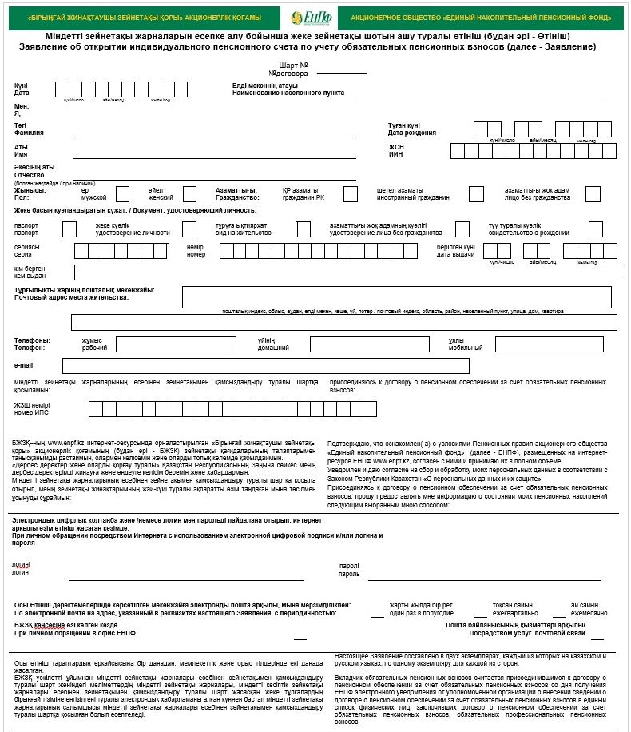

|  |  |
| --- | --- |
|  | Appendix 2 |
|  | to Pension Rules of the single |
|  | accumulative pension fund |

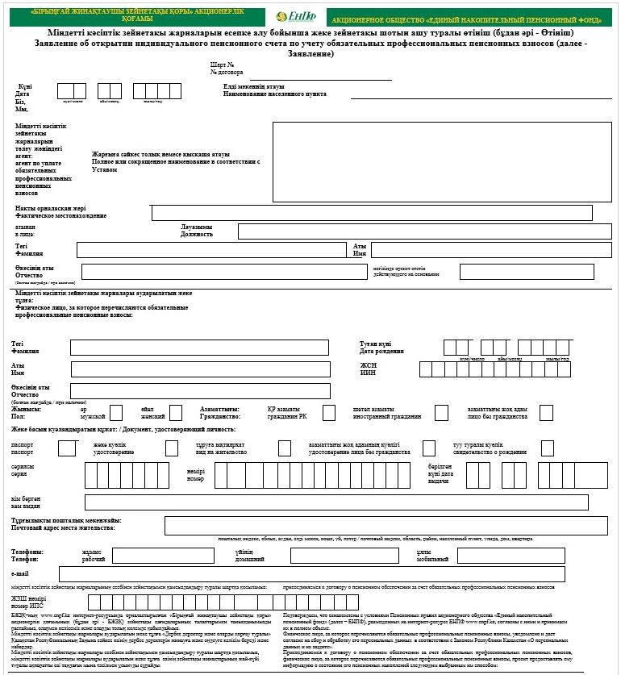

© 2012. «Institute of legislation and legal information of the Republic of Kazakhstan» of the Ministry of Justice of the Republic of Kazakhstan