On some issues concerning special economic zones
Unofficial translation
Resolution of the Government of the Republic of Kazakhstan No. 772 dated November 24, 2017.
Unofficial translation
In accordance with subparagraph 2) of Article 10 of the Law of the Republic of Kazakhstan of April 3, 2019 "On special economic and industrial zones," the Government of the Republic of Kazakhstan hereby RESOLVED as follows:
Footnote. The preamble – in the wording of the resolution of the Government of the Republic of Kazakhstan dated 06.04.2020 No. 177.
1. "Astana-Technopolis" special economic zone shall be created for the period until 2042.
2. The attached:
Regulation on the "Astana-Technopolis" special economic zone, its target indicators of functioning and the critical level of failure to achieve target indicators;
Regulation on the "Astana - a new city" special economic zone, its target indicators of functioning and the critical level of failure to reach target indicators; shall be approved.
3. This Resolution shall be enacted from the date of its signing.
Prime Minister of
the Republic of Kazakhstan | B. Sagintayev
Approved by
Resolution of the Government of
the Republic of Kazakhstan
No. 772 dated November 24, 2017
Regulation On the "Astana-Technopolis" special economic zone 1. General provisions
1. The special economic zone "Astana - Technopolis" (hereinafter referred to as the SEZ) shall be located on the territory of the city of Nur-Sultan within the borders according to the attached plan.
The territory of the SEZ shall be 736.62 hectares and shall be an integral part of the territory of the Republic of Kazakhstan.
Footnote. Paragraph 1 as amended by the Government Resolution No. 476 dated July 31, 2018; as amended by the resolutions of the Government of the Republic of Kazakhstan dated 22.10.2019 No. 780; dated 06.04.2020 No. 177; dated 02.06.2021 No. 366.
2. The SEZ creation is aimed at:
1) innovative development of the city of Nur-Sultan by attracting investments and using existing and attracted advanced technologies, know-how, creating modern infrastructure;
2) creation of highly efficient, including high-tech and competitive productions, in the field of processing industry;
3) accelerated development of new technologies, further improvement of organizational, economic and social conditions for research, development of new technologies, and assistance in their commercialization;
4) accelerated development of the city of Nur-Sultan by attracting investments in the social sphere, in the field of healthcare.
Footnote. Paragraph 2 as amended by the resolutions of the Government of the Republic of Kazakhstan dated 22.10.2019 No. 780; dated 06.04.2020 No. 177.
3. The activities of the SEZ shall be regulated by the Constitution of the Republic of Kazakhstan, the Law of the Republic of Kazakhstan "On special economic and industrial zones," this Regulation and other regulatory legal acts of the Republic of Kazakhstan.
Footnote. Paragraph 3 in the wording of the resolution of the Government of the Republic of Kazakhstan dated 06.04.2020 No. 177.
4. The list of priority activities of the SEZ corresponding to the goals of its creation, as well as the procedure for including priority activities in the specified list shall be determined by the authorized state body, carrying out state regulation in the field of creation, functioning and abolition of special economic and industrial zones, in agreement with the authorized state planning body and the authorized body, providing leadership in the field of ensuring tax revenues and other mandatory payments to the budget..
Footnote. Paragraph 4 in the wording of the resolution of the Government of the Republic of Kazakhstan dated 02.06.2021 No. 366.
5. Implementation of the projects on types of activities will be mainly carried out using projects on scientific development of the "Astana Business Campus" park of the autonomous organization of education "Nazarbayev University".
2. Management of SEZ
6. SEZ management shall be carried out in accordance with the Law of the Republic of Kazakhstan "On special economic and industrial zones."
Footnote. Paragraph 6 in the wording of the resolution of the Government of the Republic of Kazakhstan dated 06.04.2020 No. 177.
3. Taxation in the territory of SEZ
7. Taxation in the territory of the SEZ shall be regulated by the tax legislation of the Republic of Kazakhstan.
4. Customs regulation
8. Customs regulation on the SEZ territory is carried out in accordance with the provisions of the customs legislation of the Eurasian Economic Union and the Republic of Kazakhstan.
9. The customs procedure of a free customs zone shall be applied within the SEZ or a part thereof, on which priority activities will be carried out.
The goods covered by customs procedure of a free customs zone, are those intended for placement and (or) use on the SEZ territory by persons carrying out priority activities in the SEZ territory according to the agreement on implementation of activities as the SEZ participant SEZ.
10. The SEZ territory is a zone of customs control. The SEZ boundaries along its perimeter are settled and equipped with special fences for the purpose of customs control.
11. On the SEZ territory, places for temporary storage of goods may be created in the manner prescribed by the customs legislation of the Eurasian Economic Union and the Republic of Kazakhstan.
12. Goods covered by the customs procedure of the free customs zone, as well as goods of the Eurasian Economic Union not covered by the customs procedure of the free customs zone, and foreign goods covered by other customs procedures may be placed and used on the SEZ territory.
13. Goods imported into the SEZ territory and covered by the customs procedure of the free customs zone are considered as being outside the customs territory of the Eurasian Economic Union for the purposes of applying customs duties and taxes, as well as non-tariff regulation measures.
14. Customs operations related to temporary storage, customs declaration, customs clearance and release of goods, as well as the conduct of customs control in the SEZ territory, are carried out in the manner prescribed by the customs legislation of the Eurasian Economic Union and the Republic of Kazakhstan.
5. Environmental protection
15. Implementation of activities in the SEZ is based on the rational and effective use of natural resources by creating the conditions for transition to sustainable development and protection of the environment based on the balance of economic, social and environmental aspects of improving the life quality.
6. Procedure and terms for the abolition of SEZ
16. The SEZ shall be abolished upon expiry of the period for which it was established. The SEZ shall be abolished by the Government of the Republic of Kazakhstan.
7. Final Provisions
17. Early abolition of the SEZ shall be carried out in accordance with the Law of the Republic of Kazakhstan dated April 3, 2019 "On special economic and industrial zones."
Footnote. Paragraph 17 in the wording of the resolution of the Government of the Republic of Kazakhstan dated 22.10.2019 No. 780.
18. The SEZ activities, not arranged by this Regulation, shall be carried out in accordance with the applicable legislation of the Republic of Kazakhstan and the Eurasian Economic Union.
Supplement
to Regulation On the
“Astana-Technopolis” special
economic zone
Plan of borders of special economic zone “Astana-Technopolis”
Footnote. The plan in the wording of the resolution of the Government of the Republic of Kazakhstan dated 02.06.2021 No. 366.

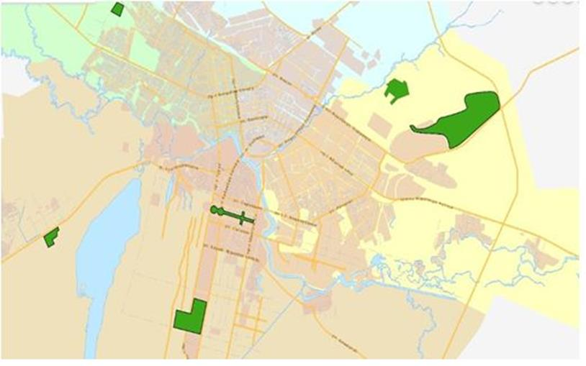

The territory of the special economic zone "Astana-Technopolis." S = 736.62 ha.
Approved
by Resolution No. 772
of the Government of the
Republic of Kazakhstan
dated November 24, 2017
Target indicators of functioning of the special economic zone "Astana-Technopolis"
Footnote. Target indicators in the wording of the resolution of the Government of the Republic of Kazakhstan dated 06.04.2020 No. 177.
№ r/n | Goals, objectives and indicators | Unit of measure | Achievement of the target indicator by 2022 | Achievement of the target indicator by 2027 | Achievement of the target indicator by 2032 | Achievement of the target indicator by 2037 | Achievement of the target indicator by 2042
1 | 2 | 3 | 4 | 5 | 6 | 7 | 8
1 | Total investments, including: | KZT billion | 5,2 | 40 | 100 | 200 | 300
1.1 | volume of foreign investment | KZT billion | 1,7 | 8 | 20 | 40 | 60
1.2 | volume of domestic investments | KZT billion | 3,5 | 32 | 80 | 160 | 240
2 | Scope of production of goods and services (works) on the territory of the SEZ | KZT billion | 1,6 | 100 | 150 | 250 | 400
3 | Number of participants (companies) | units | 12 | 38 | 62 | 75 | 85
1 | 2 | 3 | 4 | 5 | 6 | 7 | 8
4 | Number of persons engaged in auxiliary activity | person | 7 | 13 | 35 | 47 | 53
5 | Number of workplaces created on the territory of the SEZ | person | 1000 | 3000 | 4500 | 6000 | 6000
6 | Share of Kazakhstan content in the total volume of production in the territory of the SEZ | % | 15% | 20% | 25% | 30% | 35%
7 | Level of innovative activity of enterprises | % | 3,7 | 4,8 | 6,2 | 8 | 10
* Indicators have been indicated on a cumulative basis
Approved by Resolution
No. 772 of the Government of the
Republic of Kazakhstan
dated November 24, 2017
REGULATION
On the "Astana - new city" special economic zone
1. General Provisions
1. The special economic zone "Astana - New City" (hereinafter hereinafter referred to as the SEZ) shall be located within the territorial border of the city of Nur-Sultan, within the borders according to the attached plan.
The territory of the SEZ "Astana - New City" shall be an integral part of the territory of the Republic of Kazakhstan and amounts to 15,421,72 hectares. The SEZ territory shall include: industrial park No. 1 with an area of 598.1 hectares, a development zone with an area of 3269 hectares, a renovation zone with an area of 5134 hectares, an urban light rail line with an area of 72.41 hectares and the territory of a local executive body with an area of 1.9 hectares.
Footnote. Paragraph 1 in the wording of the resolution of the Government of the Republic of Kazakhstan dated 22.10.2019 No. 780.
2. The SEZ creation is aimed at:
1) accelerated development of the city of Nur-Sultan by attracting investments and using advanced technologies in construction, as well as the creation of modern infrastructure;
2) Creation of highly efficient, including high-tech and competitive productions, development of new types of products.
Footnote. Paragraph 2 as amended by the resolution of the Government of the Republic of Kazakhstan dated 22.10.2019 No. 780.
3. Kinds of activities in the territory of SEZ are:
1) Manufacturing, except for:
Production of beverages;
Production of tobacco products;
Manufacture of wooden and cork products, except furniture;
Manufacture of products made of straw and plaiting materials;
Printing and playback of recorded material;
Repair and installation of machinery and equipment;
2) Warehousing and auxiliary transport activities;
3) Construction and commissioning of infrastructure, administrative and residential facilities in accordance with the design estimates;
4) Construction and commissioning of hospitals, polyclinics, schools, kindergartens, museums, theaters, higher and secondary educational institutions, libraries, palaces of schoolchildren, sports complexes in accordance with design estimates;
5) Construction and commissioning of facilities intended directly for implementation of the activity kinds specified in subparagraphs 1) and 2) of this paragraph, within the design estimates.
4. The activities of the SEZ shall be regulated by the Constitution of the Republic of Kazakhstan, the Law of the Republic of Kazakhstan dated April 3, 2019 "On special economic and industrial zones" and other legislation of the Republic of Kazakhstan.
If an international treaty ratified by the Republic of Kazakhstan establishes rules other than those contained in the legislation on special economic zones, the rules of the international treaty shall be applied.
Footnote. Paragraph 4 as amended by the resolution of the Government of the Republic of Kazakhstan dated 06.04.2020 No. 177.
5. A special legal regime shall be established on the territory of the SEZ.
2. Management of SEZ
6. The SEZ management shall be carried out in accordance with the Law of the Republic of Kazakhstan dated April 3, 2019 "On special economic and industrial zones."
Footnote. Paragraph 6 in the wording of the resolution of the Government of the Republic of Kazakhstan dated 06.04.2020 No. 177.
7. Financing of the state institution of the local executive body of the capital shall be implemented at the expense of local budget in accordance with the legislative acts of the Republic of Kazakhstan.
3. Taxation in the territory of SEZ
8. Taxation in the SEZ territory shall be regulated by the tax legislation of the Republic of Kazakhstan.
4. Customs regulation
9. Customs regulation on the SEZ territory is carried out in accordance with the provisions of the customs legislation of the Eurasian Economic Union and the Republic of Kazakhstan.
10. The customs procedure of the free customs zone is applied on a part of the SEZ territory, where priority activities will be carried out.
The goods covered by customs procedure of a free customs zone, are those intended for placement and (or) use on the SEZ territory by persons carrying out priority activities in the SEZ territory according to the agreement on implementation of activities as the SEZ participant.
11. The territory of the SEZ is a zone of customs control. The boundaries of the SEZ, at which the customs procedure of the free customs zone is applied, along its perimeter are equipped in accordance with the customs legislation of the Republic of Kazakhstan for the purposes of customs control.
12. On the SEZ territory, places for temporary storage of goods may be created in the order established by the customs legislation of the Eurasian Economic Union and the Republic of Kazakhstan.
13. Goods covered by the customs procedure of the free customs zone, as well as goods of the Eurasian Economic Union not covered by the customs procedure of the free customs zone, and foreign goods covered by other customs procedures may be placed and used on the SEZ territory. 14. Goods imported into the territory of SEZ and covered by the customs procedure of the free customs zone are considered as being outside the customs territory of the Eurasian Economic Union for the purposes of application of customs duties, taxes, as well as non-tariff regulation measures.
15. Customs operations related to temporary storage, customs declaration, customs clearance and release of goods, as well as the conduct of customs control in the SEZ territory, are carried out in the manner prescribed by the customs legislation of the Eurasian Economic Union and the Republic of Kazakhstan.
5. Order of the foreign citizens’ sojournment on SEZ the territory
16. The procedure for entry, exit, transit and stay of foreign citizens and stateless persons, as well as their vehicles, established by the legislation of the Republic of Kazakhstan and international agreements ratified by the Republic of Kazakhstan, is in effect on the SEZ territory.
6. Final Provisions
17. The conditions set forth in this Regulation may be amended by a resolution of the Government of the Republic of Kazakhstan.
18. The SEZ shall be abolished on the grounds provided for by the Law of the Republic of Kazakhstan of April 3, 2019 "On special economic and industrial zones”.
Footnote. Paragraph 18 in the wording of the resolution of the Government of the Republic of Kazakhstan dated 22.10.2019 No. 780.
19. Excluded by the resolution of the Government of the Republic of Kazakhstan dated 22.10.2019 No. 780.
20. Excluded by the resolution of the Government of the Republic of Kazakhstan dated 22.10.2019 No. 780.
21. Excluded by the resolution of the Government of the Republic of Kazakhstan dated 22.10.2019 No. 780.
22. The SEZ activities, not arranged by this Regulation, shall be carried out in accordance with the applicable legislation of the Republic of Kazakhstan.
Supplement to Regulation
On the "Astana-new city" special
economic zone
The plan of bourders of special economic zone “Astana - New City”
Footnote. The plan in the wording of the resolution of the Government of the Republic of Kazakhstan dated 22.10.2019 No. 780.

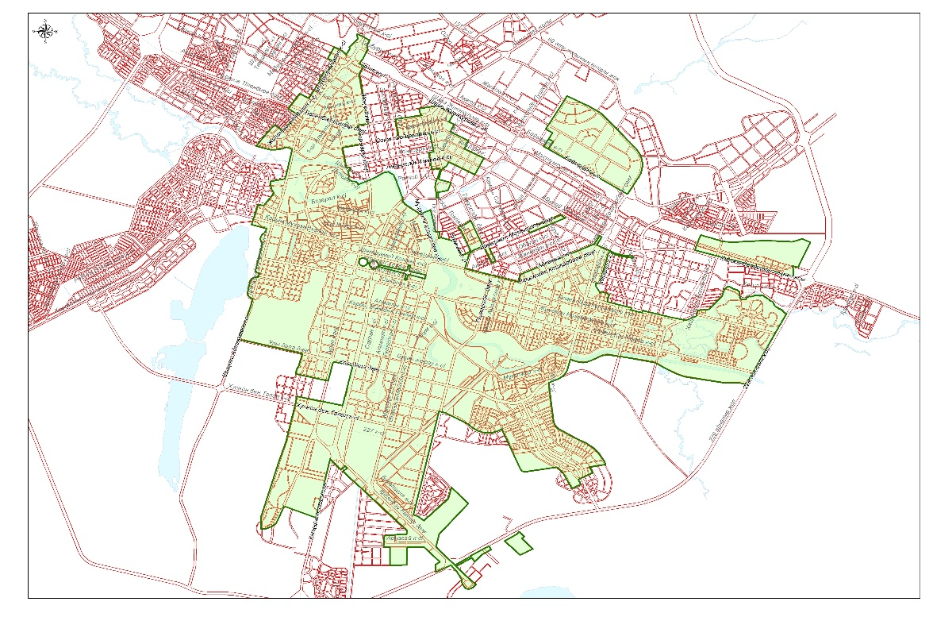

Approved by Resolution
No. 772 of the Government of the
Republic of Kazakhstan
dated November 24, 2017
Target indicators of the functioning of the "Astana - a new city" special economic zone,
a critical level of failure to reach target indicators
Footnote. Target indicators as amended by the resolution of the Government of the Republic of Kazakhstan dated 22.10.2019 No. 780.

Ref No. | Goals, objectives and indicators (names) | Unit of meas.* | Basic period (2011) | Achievement by 2017
 |  |  |  | 2012 | 2013 | 2014 | 2015 | 2016 | 2017 | Critical Level
1 | 2 | 3 | 4 | 5 | 6 | 7 | 8 | 9 | 10 | 11
1 | Total amount of investments including (growing):** | KZT bln | 911 | 975,8 | 1040,6 | 1105,4 | 1170,2 | 1235 | 1 300 | 1 100
 | Volume of foreign investments | KZT bln | 101 | 101,2 | 101,3 | 101,5 | 101,6 | 101,8 | 102 | 101
 | Volume of domestic investments | KZT bln | 810 | 874,6 | 939,2 | 1003,8 | 1068,4 | 1133 | 1 198 | 999
2 | Volume of production of goods and services (works) in the territory of SEZ** | KZT bln | 35 | 40,8 | 46,6 | 52,4 | 58,2 | 64 | 70 | 40
3 | Number of participants | unit | 24 | 28 | 33 | 37 | 41 | 45 | 50 | 30
4 | Number of persons carrying out auxiliary activities | person | 50 | 58 | 64 | 72 | 81 | 89 | 100 | 50
5 | Number of jobs created in the territory of SEZ | person | 950 | 1375 | 1800 | 2225 | 2650 | 3075 | 3 500 | 1 500
6 | Share of domestic content in total production in the territory of SEZ | % | 15 | 20 | 25 | 30 | 35 | 40 | 45 | 25
Table continued
Ref No | Achievement by 2022 |  |  |  |  |  | Achievement by 2027
 | 2018 | 2019 | 2020 | 2021 | 2022 | Critical level | 2023 | 2024 | 2025 | 2026 | 2027 | Critical level
 | 12 | 13 | 14 | 15 | 16 | 17 | 18 | 19 | 20 | 21 | 22 | 23
1 | 1350 | 1400 | 1450 | 1500 | 1550 | 1 300 | 1620 | 1690 | 1760 | 1830 | 1 900 | 1 500
 | 12 | 13 | 14 | 15 | 16 | 17 | 18 | 19 | 20 | 21 | 22 | 23
 | 104 | 105 | 107 | 108 | 110 | 102 | 111 | 112 | 113 | 114 | 115 | 110
 | 1246,4 | 1294,8 | 1343,2 | 1391,6 | 1440 | 1 198 | 1509 | 1578 | 1647 | 1716 | 1 785 | 1 390
2 | 80 | 90 | 100 | 110 | 120 | 60 | 126 | 132 | 138 | 144 | 150 | 75
3 | 52 | 55 | 58 | 60 | 62 | 35 | 64 | 67 | 70 | 75 | 80 | 50
4 | 110 | 120 | 130 | 140 | 150 | 75 | 160 | 170 | 180 | 190 | 200 | 100
5 | 3700 | 3900 | 4100 | 4300 | 4 500 | 2 000 | 4700 | 4900 | 5100 | 5300 | 5 500 | 2750
6 | 46 | 47 | 48 | 49 | 50 | 30 | 52 | 54 | 56 | 58 | 60 | 35
Note:
* - Indicator constants are given on a cumulative total;
The rate applied for calculation: 1 US dollar - 333 tenge.
** - The amount of volume of production of goods and services (works)on the SEZ territory is less than the amount of investments due to the amount of attracted investments indicating on a cumulative total from the tome of SEZ creation (2002), and the volume of production of goods and services is indicated according to the launched production since 2010. To date, 41 enterprises are functioning, 11 are under construction and 13 are at the design stage.
In the industrial park No. 1 of the city of Nur-Sultan, the volume of investments shall be KZT140,000 million, the volume of production after the enterprises shall reach their design capacity shall amount to KZT 175 720 million per year.

© 2012. «Institute of legislation and legal information of the Republic of Kazakhstan» of the Ministry of Justice of the Republic of Kazakhstan

