

**On some issues of the special economic zone "Saryarka"**

***Unofficial translation***

Decree of the Government of the Republic of Kazakhstan dated April 28, 2021 No. 277.

      Unofficial translation

      In accordance with subparagraph 2) of Article 10 of the Law of the Republic of Kazakhstan “On Special Economic and Industrial Zones”, the Government of the Republic of Kazakhstan **HEREBY DECREES**:

      Footnote. Preamble - as amended by the Decree of the Government of the Republic of Kazakhstan dated 26.04.2024 № 335.

      1. To approve the attached:

      1) Decree on the special economic zone "Saryarka";

      2) target indicators of the special economic zone "Saryarka".

      Footnote. Paragraph 1 as amended by the Decree of the Government of the Republic of Kazakhstan dated 14.08.2021 № 558.

      2. This decree enters into force from the date of its signing.

|  |  |
| --- | --- |
| *Prime-Minister of the*  *Republic of Kazakhstan* | *A. Mamin* |

|  |  |
| --- | --- |
|  | Approved by the decree of the Government  of the Republic of Kazakhstan dated April 28, 2021 № 277 |

**Regulation**   
**on special economic zone “Saryarka”**

**Chapter 1. General provisions**

      1. The special economic zone “Saryarka” (hereinafter referred to as the SEZ) shall be located on the territory of the city of Karaganda and adjacent lands of the Bukhar-Zhyrau district of the Karaganda region according to the attached plan.

      The territory of the SEZ is 940.51 hectares and shall be an integral part of the territory of the Republic of Kazakhstan. The SEZ territory shall include the Metallurgy-Metalworking industrial park with an area of 880.4 hectares and the Silicon Valley subzone with an area of 60.11 hectares.

      Footnote. Paragraph 1 – as amended by the Decree of the Government of the Republic of Kazakhstan dated 26.04.2024 № 335.

      2. SEZ is created for the following purposes:

      1) the development of the metallurgical industry and the metalworking industry, in particular the production of finished products by attracting manufacturers of world brands;

      2) the development and implementation of breakthrough investment projects for the creation and development of the metallurgical industry and the world-class metalworking industry for the deep processing of raw materials and the production of wide competitive products with high added value;

      3) improving the quality and expanding the range of products;

      4) integration of Kazakhstani products into the global system of production and marketing, creation of innovative, competitive domestic products in accordance with international standards;

      5) creation of highly efficient and innovative industries, including high-tech and competitive industries, mastering the release of new types of products;

      6) development and implementation of research and scientific and technical innovation projects for the creation and improvement of production and technologies for deep processing of raw materials;

      7) creating a favorable investment climate and attracting domestic and foreign investments for implementation of investment projects;

      8) attraction of investments in construction and integrated development of the metallurgical industry on the basis of public-private partnership mechanisms;

      9) accelerated development of the region to enhance the entry of the economy of the republic into the system of world economic relations;

      10) improvement of legal norms of market relations, introduction of modern methods of management and managing;

      11) solving social problems and increasing employment of the population;

      12) development of the coal and oil refining industry;

      13) creation of uninterrupted supply of electricity and heat.

      3. The activities of SEZs shall be regulated by the Constitution of the Republic of Kazakhstan, the Law of the Republic of Kazakhstan “On Special Economic and Industrial Zones” (hereinafter referred to as the Law), these Regulations and other regulatory legal acts of the Republic of Kazakhstan.

      Footnote. Paragraph 3 – as amended by the Decree of the Government of the Republic of Kazakhstan dated 26.04.2024 № 335.

      4. The list of priority activities of the SEZ, corresponding to the goals of its creation, as well as the procedure for including priority activities in the specified list are determined by the authorized state body that carries out state regulation in the field of creation, operation and abolition of special economic and industrial zones, in agreement with the authorized body on state planning and the authorized body for budget planning.

**Chapter 2. SEZ management**

      4. SEZ management is carried out in accordance with the Law.

**Chapter 3. Taxation in the SEZ**

      5. Taxation on the territory of the SEZ is regulated by the tax legislation of the Republic of Kazakhstan.

**Chapter 4. Customs regulation**

      6. The customs procedure of a free customs zone shall operate on the territory of a special economic zone or part thereof.

      Footnote. Paragraph 6 – as amended by the Decree of the Government of the Republic of Kazakhstan dated 26.04.2024 № 335.

      6-1. The territory of the SEZ, where the customs procedure of a free customs zone is applied, shall be a customs control zone. The territory of the SEZ must be developed for the purpose of customs control. Requirements for the development of the territory of SEZ, including requirements for fencing and equipping the perimeter of such territory with a video surveillance system, shall be established by the authorized body in the field of customs affairs.

      Footnote. Chapter 4 was supplemented with Paragraph 6-1 in accordance with the Decree of the Government of the Republic of Kazakhstan dated 26.04.2024 № 335.

**Chapter 5. Procedure for the stay of foreign citizens and stateless persons in the territory of the SEZ**

      7. The procedure for entry, exit, transit and stay of foreign citizens and stateless persons, as well as their vehicles, established by the legislation of the Republic of Kazakhstan and international agreements ratified by the Republic of Kazakhstan, is in force on the territory of the SEZ.

**Chapter 6. Environmental protection**

      8. The activity of the SEZ in terms of environmental regulation is carried out in accordance with the environmental legislation of the Republic of Kazakhstan and is based on the rational and efficient use of natural resources by creating conditions for the transition to sustainable development and environmental protection based on a balance of economic, social and environmental aspects of improving the quality of life.

**Chapter 7. Final provisions**

      9. The conditions established in this Regulation may be changed by a decree of the Government of the Republic of Kazakhstan.

      10. Early abolition of the SEZ is carried out in accordance with the Law.

      11. The activities of the SEZ, not regulated by these Regulations, are carried out in accordance with the current legislation of the Republic of Kazakhstan and the Eurasian Economic Union.

|  |  |
| --- | --- |
|  | Appendix to the Regulation on special  economic zone "Saryarka" |

**Plan of the boundaries of the special economic zone "Saryarka"**

      Footnote. Appendix - as amended by the Decree of the Government of the Republic of Kazakhstan dated 26.04.2024 № 335.

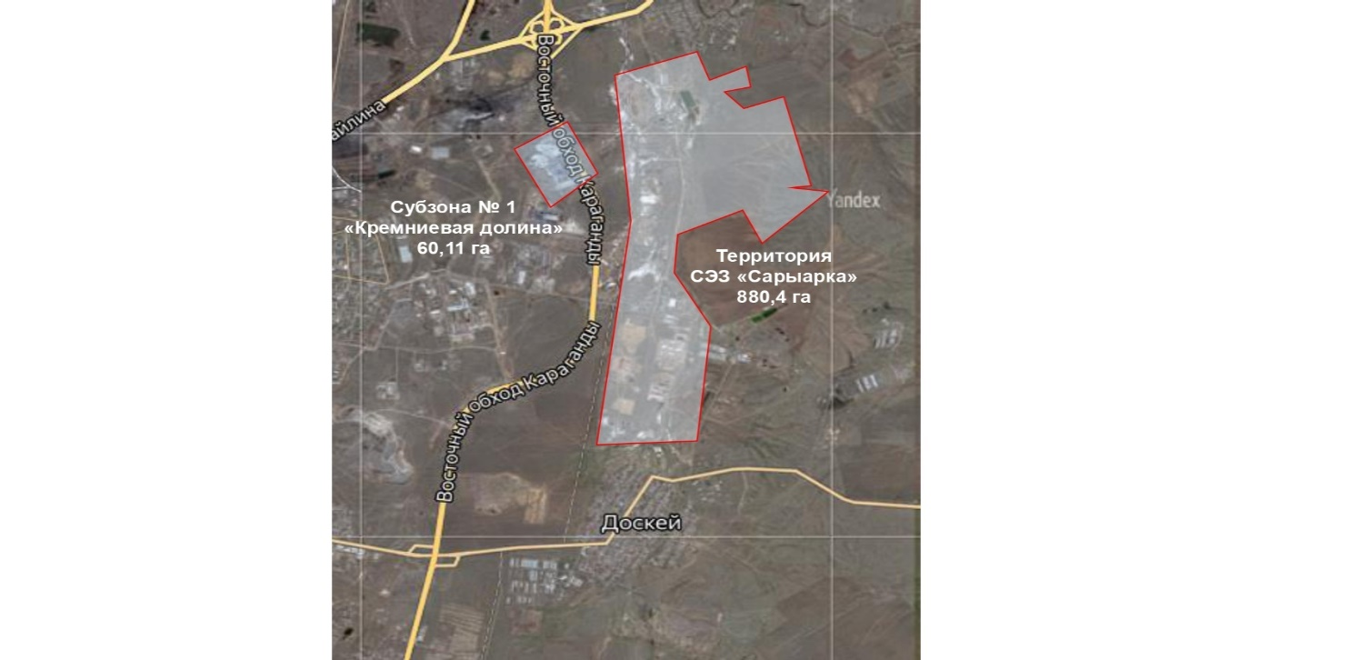

|  |  |  |
| --- | --- | --- |
| № | Name of zones: | Area, hectare |
| 1. | Special economic zone "Saryarka" | 880,4 |
| 2. | Subzone "Silicon Valley" | 60,11 |
|  | Total: | 940,51 |

|  |  |
| --- | --- |
|  |  |
|  | Approved by the decree of the Government  of the Republic of Kazakhstan  dated April 28, 2021 № 277 |

**Target indicators of the special economic zone "Saryarka"**

      Footnote. The title as amended by the Decree of the Government of the Republic of Kazakhstan dated 14.08. 2021 № 558.

|  |  |  |  |  |  |  |  |
| --- | --- | --- | --- | --- | --- | --- | --- |
| № | Goals, objectives and indicators (names) | Unit of measurement | Base period (2020) | Target indicator of achievement by 2025 | Target indicator of achievement by 2030 | Target indicator of achievement by 2035 | Target indicator of achievement by 2037 |
| 1 | 2 | 3 | 4 | 5 | 6 | 7 | 8 |
| 1 | Total investment, including: | Billon of tenge | 91,8 | 292 | 355 | 423 | 455 |
| 1.1. | volume of foreign investment | Billon of tenge | 9,4 | 39,4 | 84,9 | 130,4 | 144,5 |
| 1.2. | volume of domestic investment | Billon of tenge | 82,4 | 252,6 | 270,1 | 292,6 | 310,5 |
| 2 | Volume of production of goods and services (works) | Billon of tenge | 110,7 | 410,3 | 1168,8 | 1264,8 | 1552,2 |
| 3 | Number of participants | companies | 19 | 24 | 27 | 30 | 31 |
| 4 | Number of persons carrying out ancillary activities | ppl | 10 | 35 | 55 | 65 | 75 |
| 5 | Number of workplaces | ppl | 645 | 2000 | 3 000 | 4 000 | 4 500 |
| 6 | Share of local content in total production | % | 50 | 55 | 60 | 65 | 70 |

© 2012. «Institute of legislation and legal information of the Republic of Kazakhstan» of the Ministry of Justice of the Republic of Kazakhstan