On creation of a special economic zone "Park of Innovative Technologies"
Unofficial translation
Decree of the President of the Republic of Kazakhstan dated August 18, 2003 N 1166.
Unofficial translation
Footnote. The title shall be in the wording of the Decree of the President of the Republic of Kazakhstan dated 08.12.2011 No. 193.
In accordance with the Law of the Republic of Kazakhstan dated July 21, 2011 "On Special Economic Zones in the Republic of Kazakhstan" and in order to create new competitive industries in the country and make fuller use of the scientific, technical and innovative potential of the Republic of Kazakhstan, I HEREBY RESOLVE:
Footnote. The preamble shall be in the wording of the Decree of the President of the Republic of Kazakhstan dated 08.12.2011 No. 193.
1. To create a special economic zone "Park of Innovative Technologies" (hereinafter - SEZ) for the period until January 1, 2028.
Footnote. Paragraph 1 as amended by the Decree of the President of the Republic of Kazakhstan dated 08.12.2011 No. 193.
2. To approve the attached:
1) Regulation on the SEZ;
2) target performance indicators and critical level of failure to achieve the SEZ target indicators.
Footnote. Paragraph 2 as amended by the Decree of the President of the Republic of Kazakhstan dated 29.12.2012 No. 457.
3. The Government of the Republic of Kazakhstan to take measures to ensure the activities of the SEZ.
4. The Administration of the President of the Republic of Kazakhstan shall be authorized to control the implementation of this Decree.
5. This Decree shall enter into force on October 1, 2003.
President of the
Republic of Kazakhstan
Approved by
Decree of the President of the
Republic of Kazakhstan
dated August 18, 2003
No. 1166
Resolution on special economic zone
"Park of innovative technologies"
Footnote. Regulation as amended by the Decree of the President of the Republic of Kazakhstan dated 08.12.2011 No. 193.
1. General provisions
1. The special economic zone "Park of Innovative Technologies" (hereinafter referred to as the SEZ) shall be located in the Alatau village of the Medeu district of Almaty and the adjacent lands of the Almaty region in accordance with the attached plan.
The territory of the SEZ shall be 163.02 hectares and shall be an integral part of the territory of the Republic of Kazakhstan.
2. The SEZ shall be created for:
1) technological development of the following areas:
information and communication technologies;
technologies in the field of telecommunications and communications;
electronics and instrumentation;
renewable energy sources, resource conservation and efficient nature management;
technologies in the field of creation and application of materials for various purposes;
technologies in production, transportation and refining of oil and gas;
2) enhancing the entry of the economy of the Republic of Kazakhstan into the system of world economic relations;
3) creation of highly efficient, including high-tech and competitive industries, development of new types of products, attraction of investment.
Footnote. Paragraph 2 as amended by the Decree of the President of the Republic of Kazakhstan dated 25.11.2016 No. 377 (shall be enforced from the date of its first official publication).
3. The types of activities on the territory of the SEZ shall be:
1) manufacturing industry, except for:
food production;
beverage production;
production of tobacco products;
production of textiles;
clothing production;
production of wood and cork products, except furniture;
production of straw products and materials for weaving;
production of chemical industry products; metallurgy industry;
furniture manufacturing;
vehicle manufacturing;
repair and installation of machinery and equipment;
2) information and communication;
3) professional, scientific and technical activities;
4) construction and commissioning of facilities intended directly for implementation of the types of activities provided for in subparagraphs 1), 2), 3) of this paragraph, within the framework of design estimates.
Footnote. Paragraph 3 shall be in the wording of the Decree of the President of the Republic of Kazakhstan dated 25.11.2016 No. 377 (shall be enforced from the day of its first official publication).
4. Within the framework of the SEZ, favorable conditions shall be established for creative and productive work in the field of innovation of higher educational institutions, including the International University of Information Technologies, vocational educational institutions, and research institutes. The directions of their activities within the framework of the SEZ shall be regulated in accordance with paragraph 3 of this Regulation, as well as the current legislation of the Republic of Kazakhstan.
5. For SEZ participants in the field of information and communication technologies and innovative technologies, the requirement to carry out activities on the territory of the SEZ shall not be a prerequisite until January 1, 2018 for the following activities:
1) design, development, introduction, pilot production and production of software, databases and hardware for information and communication technologies, as well as data center services, electronic services;
2) the conduct of research and development works on creation and introduction of projects in the field of information and communication technologies.
Footnote. Paragraph 5 as amended by the Decree of the President of the Republic of Kazakhstan dated 25.11.2016 No. 377 (shall be enforced from the day of its first official publication).
6. The activities of SEZ shall be regulated by the Constitution of the Republic of Kazakhstan, the Law of the Republic of Kazakhstan dated July 21, 2011 "On special economic zones in the Republic of Kazakhstan" and other regulatory legal acts of the Republic of Kazakhstan.
Activities related to the production of excisable goods shall be prohibited on the territory of the SEZ.
If an international treaty ratified by the Republic of Kazakhstan establishes rules other than those contained in the legislation of the Republic of Kazakhstan on special economic zones, then the rules of the international treaty shall apply.
2. Management of SEZ
7. Management of SEZ shall be carried out in accordance with the Law of the Republic of Kazakhstan "On Special Economic Zones in the Republic of Kazakhstan".
8. The management body of the SEZ shall be a management company - a legal entity created in accordance with the Law of the Republic of Kazakhstan "On Special Economic Zones in the Republic of Kazakhstan" in the legal form of a joint stock company to ensure the functioning of a special economic zone.
9. The functions of the SEZ management body shall include:
1) interaction with government bodies on the functioning of the SEZ;
2) provision of land plots for secondary land use (sublease) and the lease (sublease) of infrastructure facilities to persons carrying out auxiliary types of activities;
3) conclusion and termination of agreements on implementation of activities;
4) reporting to the authorized body on the results of the activities of the SEZ in the manner, established by the authorized body, based on the annual reports of the participants of the SEZ;
5) attraction of participants in a special economic zone;
6) attraction of investment for construction of infrastructure and for other types of activities of special economic zones;
7) construction of infrastructure in accordance with the approved feasibility study on land plots not transferred to the participants of the special economic zone;
8) organization of the reception point for the functioning of the public services center on "one window" principle;
9) confirmation of the actual consumption of imported goods in the implementation of activities that meet the goals of creating a special economic zone;
10) monitoring the fulfillment of the terms of agreements on implementation of activities.
3. Taxation in the territory of SEZ
10. Taxation in the territory of SEZ shall be regulated by the tax legislation of the Republic of Kazakhstan.
4. Customs regulation
11. The territory of the SEZ shall be a part of the customs territory of the Republic of Kazakhstan with the customs regime of a free customs zone in accordance with the customs legislation of the Republic of Kazakhstan. The borders of the SEZ along its perimeter shall be equipped with a special fence.
12. Customs clearance and control in the territory of SEZ shall be carried out in the manner, determined by the customs legislation of the Republic of Kazakhstan.
13. The list of goods necessary to achieve the goal of creating a SEZ shall include:
1) machinery, equipment, goods and materials necessary for construction and commissioning of facilities on the territory of the SEZ, in accordance with the design estimates;
2) goods intended for processing (excluding excisable goods), in accordance with the criteria for sufficient processing of goods;
3) machinery and tools, equipment, special vehicles, materials, goods and semi-finished products necessary to ensure production, in accordance with the main types of activities specified in paragraph 3 of this Regulation;
4) goods and materials necessary for research and developmental works and production in the areas specified in paragraph 2 of this Regulation.
The nomenclature of goods referred to in part one of this paragraph shall be approved by the Government of the Republic of Kazakhstan in accordance with the Commodity Nomenclature of Foreign Economic Activity.
On the territory of the SEZ, the following operations shall be allowed with goods placed under the customs regime of a free customs zone:
1) ensuring the safety of goods;
2) processing of goods;
3) operation and use of goods and equipment necessary to achieve the goals of creating a SEZ, in accordance with the main types of activities in accordance with this Regulation;
4) preparation of goods for sale and transportation;
5) compliance with the requirements of technology for construction and industrial production.
5. Procedure for the stay of foreign citizens in the territory of SEZ
14. On the territory of the SEZ, the procedure for entry, exit, transit and stay of foreign citizens and stateless persons, as well as their vehicles, shall be in effect, established by the legislation of the Republic of Kazakhstan and international agreements to which the Republic of Kazakhstan is a party.
6. Final provisions
15. The conditions established in this Regulation may be amended by the Decree of the President of the Republic of Kazakhstan.
16. The abolition of the SEZ shall be carried out in accordance with the Law of the Republic of Kazakhstan "On Special Economic Zones in the Republic of Kazakhstan".
17. The activities of the SEZ not regulated by this Regulation shall be carried out in accordance with the current legislation of the Republic of Kazakhstan.
ANNEX
to the Regulation on special
economic zone
"Park of innovative technologies",
approved by the Decree of the
President of the
Republic of Kazakhstan
dated August 18, 2003 No. 1166
Plan of the territory of the special economic zone
"Park of innovative technologies"
(S total = 163.02 hectares)

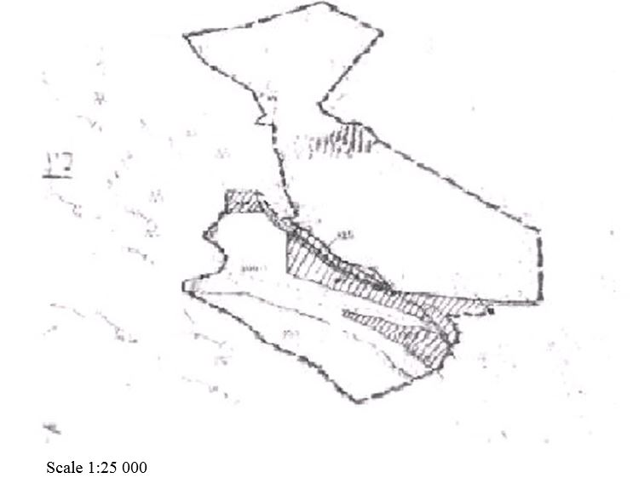

APPROVED
by the Decree of the
President of the
Republic of Kazakhstan
dated August 18, 2003
No. 1116
TARGET INDICATORS of
functioning and critical level of
failure to achieve the target indicators of special economic
zone "Park of innovative technologies"
Footnote. The decree shall be supplemented by target indicators in accordance with the Decree of the President of the Republic of Kazakhstan dated 29.12.2012 No. 457.

№ | Goals, objectives and indicators (items) | Unit of measurement | Base period (2012) | Achievement by 2015 |  | Achievement by 2020 |  | Achievement by 2028
1 | 2 | 3 | 4 | 5 | 6 | 7 | 8 | 9 | 10
1. | Total investment, including: | KZT, bln | 5 | 7 | 4 | 12 | 7 | 25 | 15
1) | Volume of foreign investment | KZT, bln | - | - | - | - | - | - | -
2) | Volume of domestic investment | KZT, bln | 5 | 7 | 4 | 12 | 7 | 25 | 15
2. | Volume of production of goods and services (works) in the territory of the special economic zone | KZT, bln | 1,89 | 16 | 8 | 26 | 13 | 53 | 33
3. | Number of participants | companies | 46 | 65 | 60 | 95 | 90 | 120 | 100
4. | Number of jobs created in the territory of the special economic zone | person | 1268 | 1688 | 1 511 | 2 718 | 2 119 | 5 826 | 3 640
5. | The share of Kazakhstani content in total production in the territory of the special economic zone | % | 50 % | 50 % | 40 % | 50 % | 40 % | 50 % | 40 %
6. | Development of information and communication technologies (ICT) by opening research laboratories and educational departments in the field of ICT | Departments | 2 | 4 | 2 | 5 | 3 | 7 | 4

© 2012. «Institute of legislation and legal information of the Republic of Kazakhstan» of the Ministry of Justice of the Republic of Kazakhstan

