

**On Approval of Regulation on “Signing of investment contract for implementation of investment project, which stipulates making of investments and provision of investment preferences” state service**

***Invalidated***
***Unofficial translation***

Order No. 585 of the Republic of Kazakhstan Minister of Investments and Development dated the 20th of May 2015; registered in the Republic of Kazakhstan Ministry of Justice on the 26th of June 2015 under No. 11457. Expired by Order of the Minister of Foreign Affairs of the Republic of Kazakhstan dated June 1, 2020 No. 11-1-4/179 (effective ten calendar days after the date of its first official publication).

      Footnote. It became invalid by Order of the Minister of Foreign Affairs of the Republic of Kazakhstan dated 01.06.2020 No. 11-1-4/179 (effective after ten calendar days after the date of its first official publication).

      In accordance with sub-paragraph 2) of article 10 of the Republic of Kazakhstan Law On State Services dated the 15th of April 2013 I hereby ORDER that:

      1. Regulation on “Signing of investment contract for implementation of investment project, which stipulates making of investments and provision of investment preferences” state service shall be approved in accordance with supplement to this order.

      2. The following shall be deemed of no longer in effect:

      1) order No.51 of the Acting Minister of Industry and New Technologies of the Republic of Kazakhstan dated the 25th of February 2014, On approval of Regulation on “Signing of investment contract for implementation of investment project, which stipulates making of investments and provision of investment preferences” state service (registered in the Registry of state registration of the Republic of Kazakhstan regulatory acts under No. 9232 and published in Kazakhstanskaya pravda newspaper No. 227 (27848) on 20th of November 2014;

      2) order No. 273 of the Minister of Investments and Development of the Republic of Kazakhstan dated the 19th of December 2014 “On amendments and additions to order No.51 of the Acting Minister of Industry and New technologies of the Republic of Kazakhstan dated the 25th of February 2014 “On Approval of Regulation on “Signing of investment contract for implementation of investment project, which stipulates making of investments and provision of investment preferences” state service” (registered in the Registry of state registration of the Republic of Kazakhstan regulatory acts under No. 10140 and published in Adilet legal system on the 12th of February 2015).

      3. The investment Committee of the Ministry of Investments and Development of the Republic of Kazakhstan (Y.K. Khairov) shall ensure:

      1) state registration of this order in the Ministry of Justice of the Republic of Kazakhstan;

      2) sending of a copy thereof for official publishing in periodical printed editions and Adilet legal system within ten calendar days after state registration of this order in the Republic of Kazakhstan Ministry of Justice;

      3) this order posting on the internet resource of the Republic of Kazakhstan Ministry of Investments and Development and on Intranet portal of state authorities;

      4) submission to Legal department of the Ministry of Investments and Development ща the Republic of Kazakhstan of data on conducting of events stipulated by sub-paragraphs 1), 2) and 3) of paragraph 2 of this order, within ten business days after state registration of this order in the Republic of Kazakhstan Ministry of Justice

      4. Supervision over this order shall be entrusted to the Vice-Minister of Investments and Development of the Republic of Kazakhstan.

      5. This order shall be enforced upon expiry of ten calendar days after the day of its first official publication.

|  |  |
| --- | --- |
| *Minister*  *of Investments and Development*  *of the Republic of Kazakhstan* | *A. Issekeshev* |

|  |  |
| --- | --- |
|  | Approved by Order No. 585 of the Republic of Kazakhstan Minister of investments and development dated the 20th of May 2015 |

**Regulation on “Signing of investment contract for implementation of investment project, which stipulates making of investments and provision of investment preferences” state service**

**1. General provisions**

      1. “Signing of investment contract for implementation of investment project, which stipulates making of investments and provision of investment preferences” state service (hereinafter referred to as state service) shall be provided by the investment Committee of the Ministry of Investments and Development of the Republic of Kazakhstan (hereinafter referred to as service provider).

      Service provider shall provide the receipt of applications issue of results of state service rendering.

      2. Format of state service provision: paper.

      3. The result of state service provision consists in signing of investment contract for implementation of investment project, which stipulates making of investments and provision of investment preferences (hereinafter referred to as Contract).

      Format for submission of the state service provision result provision: paper.

**2. Description of the sequence of actions of structural subdivisions (employees) of service provider in the process of providing the state service**

      4. The basis for commencement of the procedure (action) for provision of state service is the application filing according to paragraph 9 of the State service standard “Signing of investment contract for implementation of investment project, which stipulates making of investments and provision of investment preferences” approved by order No.478 of the Minister of Investments and Development of the Republic of Kazakhstan dated the 21st of April 2015 (registered in the Registry of state registration of regulatory legal acts under No. 11216).

      5. Content of each procedure (action) included in the state service provision process, period of its implementation:

      1) receipt and registration of application by service provider's administrative office specialist with assignment of registration number and date within fifteen minutes;

      2) application consideration by Investment preferences administration (hereinafter referred to as Administration) of service provider within eighteen business days from the moment of application registration;

      3) in case documents comply with the requirements established by article 286 of the Republic of Kazakhstan Entrepreneurship code dated the 29th of October 2015 service provider's director shall issue an order concerning conclusion of the Contract within two business days according to results of documents consideration;

      4) the draft Contract preparation by Administration within ten business days from the day of adoption of the order related to Contract signing;

      5) registration of Contract signed by the parties within five business days;

      6) issue of registered Contract to service receiver.

      Reference. Paragraph 5 as amended by order No.208 of the Republic of Kazakhstan Minister of Investments and Development dated 23.02.2016 (shall be brought to effect upon expiry of ten calendar days after its first official publication).

      6. The result of procedure (action) of state service provision, which serves as a basis for commencement of performance of the following procedure (action):

      1) registration of documents submitted by service receiver and required for state service rendering in service provider's administrative office and their transfer to service provider's director;

      2) resolution of service provider's director for consideration by the Administration;

      3) order of service provider's director;

      4) preparation of draft Contract;

      5) registration of Contract by service provider.

**3. Description of procedure of service provider's structural subdivisions (employees) in the process of state service provision**

      7. List of structural subdivisions (employees) of service provider, who participate in the process of state service provision:

      1) service provider's director and (or) his deputy;

      2) Administration director;

      3) responsible executive;

      4) administrative office specialist.

      8. Description of sequence of procedures (actions) between structural subdivisions:

      1) documents shall be registered by administrative office specialist with assignment of registration number and date, after which they shall be transmitted to the service provider's first director or his deputy within fifteen minutes;

      2) service provider's director or his deputy shall transmit documents to Administration head within three hours;

      3) Administration head within one hour shall determine responsible executive and shall transmit documents for consideration;

      4) responsible executive shall consider the documents within eighteen business days from the moment of the application registration;

      5) service provider's director in case of document non-conformity s to requirements established by article 286 of Entrepreneur Code of the Republic of Kazakhstan dated the 29th of October 2015 shall within two business days issue an order concerning the Contract signing according to results of documents consideration;

      6) responsible executive within ten business days from the date of signing an order about signing of Contract shall prepare draft Contract for signing and shall send it to service receiver;

      7) draft Contract signed by the parties shall be registered by service provider within five business days;

      8) responsible executive shall transmit the Contract to administrative office specialist on the day of registration thereof;

      9) administrative office specialist shall issue registered Contract to service receiver.

      Reference. Paragraph 8 as amended by order No.208 of the Minister of Investments and Development of the Republic of Kazakhstan dated 23.02.2016 (shall be brought to effect upon expiry of ten calendar days after its first official publication).

      9. Detailed description of sequence of procedures (actions) of interaction of service provider's structural subdivisions (employees) in the process of state service provision shall be shown in the reference book of business processes for provision of “Signing of investment contract for implementation of investment project, which stipulates making of investments and provision of investment preferences” state service according to supplement to this Regulation.

      Reference. Paragraph 9 as amended by order No.208 of the Minister of Investments and Development of the Republic of Kazakhstan dated 23.02.2016 (shall be brought to effect upon expiry of ten calendar days after the day of its first official publication).

|  |  |
| --- | --- |
|  | Supplement to Regulation on “Signing of investment contract for implementation of investment project, which stipulates making of investments and provision of investment preferences” state service |

**Reference book of business processes of providing the “Signing of investment contract for implementation of investment project, which stipulates making of investments and provision of investment preferences” state service**

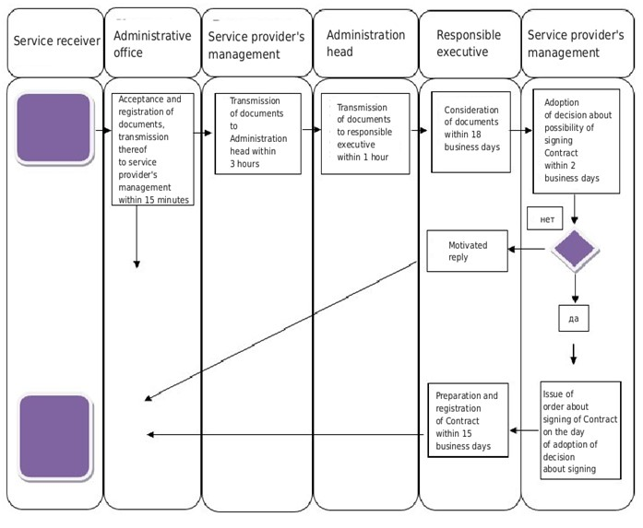

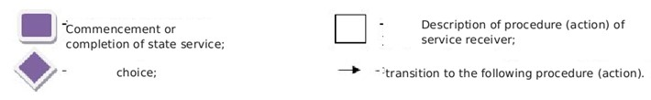

© 2012. «Institute of legislation and legal information of the Republic of Kazakhstan» of the Ministry of Justice of the Republic of Kazakhstan