

**On approval of the Regulations of the state service "Issue of an application for an investor visa for non-residents of the Republic of Kazakhstan and persons carrying out investment activities in the territory of the Republic of Kazakhstan"**

***Invalidated***
***Unofficial translation***

Order No. 489 of the Acting Minister for Investments and Development of the Republic of Kazakhstan, dated June 15, 2016. Registered by the Ministry of Justice of the Republic of Kazakhstan on July 19, 2016 under No. 13946. Expired by Order of the Minister of Foreign Affairs of the Republic of Kazakhstan dated June 3, 2020 No. 11-1-4/184

      Footnote. Expired by Order of the Minister of Foreign Affairs of the Republic of Kazakhstan dated June 03, 2020 No. 11-1-4/184 (effective ten calendar days after the date of its first official publication).

      In accordance with subparagraph 2) of Article 10 of the Republic of Kazakhstan Law, dated April 15, 2013 "On state services" **I hereby ORDER that**:

      1. To approve the attached Regulations of the state service "Issue of an application for an investor visa for non-residents of the Republic of Kazakhstan and persons carrying out investment activities in the territory of the Republic of Kazakhstan".

      2. For the Committee for investments of the Ministry of Investments and Development of the Republic of Kazakhstan to ensure:

      1) state registration of this order at the Ministry of Justice of the Republic of Kazakhstan;

      2) sending a copy of this order in printed and electronic form for official publication in printed periodicals and the Adilet information and legal system within ten calendar days after the state registration of this order at the Ministry of Justice of the Republic of Kazakhstan, as well as to the Republican Center for Legal Information within five working days from the date of receipt of the registered order for the registration in the standard reference bank of regulatory legal acts of the Republic of Kazakhstan;

      3) posting of this order on the Internet resource of the Ministry of Investments and Development of the Republic of Kazakhstan and on the intranet portal of state bodies;

      4) submission to the Legal Department of the Ministry of Investments and Development of the Republic of Kazakhstan of information on the implementation of activities provided for in subparagraphs 1), 2) and 3) of this paragraph within ten working days after the state registration of this order at the Ministry of Justice of the Republic of Kazakhstan.

      3. Supervision of the fulfilment of this order shall be entrusted to the Supervising vice Minister for Investments and Development of the Republic of Kazakhstan.

      4. This order is put into effect upon expiry of ten calendar days after the day of its first official publication.

|  |
| --- |
| *Acting* |
| *Minister for Investments and Development* |
| *of the Republic of Kazakhstan* | *Ye. Khairov* |

|  |  |
| --- | --- |
|  | Approved |
|  | by the order No. 489 of the Acting |
|  | Minister for Investments and |
|  | Development |
|  | of the Republic of Kazakhstan, |
|  | dated June 15, 2016 |

**Regulations of the state service "Issue of application for investor visa for non-residents of the Republic of Kazakhstan and persons carrying out investment activities in the territory of the Republic of Kazakhstan”**

**1. General provisions**

      1. The state service "Issue of an application for an investor visa for non-residents of the Republic of Kazakhstan and persons carrying out investment activities in the territory of the Republic of Kazakhstan" (hereinafter - state service) is provided by the Ministry for Investments and Development of the Republic of Kazakhstan (hereinafter - service provider).

Receipt of request and issue of a result of the state service provision is carried out by the service provider.

      2. Form of the state service provision: hard copy.

      3. The result of the state service provision: application for an investor visa for non-residents of the Republic of Kazakhstan and persons carrying out investment activities in the territory of the Republic of Kazakhstan under the form, in accordance with the annex 1 to the Regulations of issue of an application for an investor visa for non-residents of the Republic of Kazakhstan and persons, carrying out investments activities in the territory of the Republic of Kazakhstan, approved by the order No. 1265 of the Minister for Investments and Development of the Republic of Kazakhstan, dated December 29, 2015 (registered in Registry of state registration of regulatory law acts under No. 13039).

      Form of the state service result provision: hard copy

**2. Description of procedures of structural units (employees) of the service provider in the process of the state service provision**

      4. The grounds of the commencement of the procedure (action) for the provision of state service is the availability of a request for issue of an application for an investor visa for non-residents of the Republic of Kazakhstan and persons carrying out investment activities in the territory of the Republic of Kazakhstan under the form, in accordance with the annex 1 of the Standard of State Service “Issue of an application for an investor visa for non-residents of the Republic of Kazakhstan and persons carrying out investment activities on the territory of the Republic of Kazakhstan” (hereinafter referred to as - request) approved by the Order No. 301 of the Minister of Investments and Development of the Republic of Kazakhstan, dated March 29, 2016 (registered in the Registry of State Registration of Regulatory Legal Acts under No. 13685) (hereinafter referred to as - Standard), with the documents specified in paragraph 9 of the Standard.

      5. The content of each procedure (action) included in the process of the state service provision, duration of implementation:

      1) registration of request, issue of a receipt on acceptance of documents in accordance with annex 2 to the Standard - 15 (fifteen) minutes;

      2) transfer of the request to the head of the service provider for consideration – 1 (one) hour;

      3) endorsement of the head and appointment of the responsible structural unit – 2 (two) hours;

      4) endorsement of the head and appointment of the responsible executive employee – 2 (two) hours;

      5) consideration of the request and sending of the result of the state service provision to the head of the structural unit for approval by the responsible executive employee – 9 (nine) working days from the receipt of the request by the responsible executive employee;

      6) approval of the result of the state service provision by the head of the structural unit – 2 (two) hours;

      7) signing the result of the state service provision by the head of the service provider – 2 (two) hours;

      8) sending the result of the state service provision to the service provider’s administrative office – 1 (one) hour;

      9) sending the result of the state service provision to the service recipient by courier or mail – 1 (one) hour.

      6. The result of the procedure (action) for the state service provision, which serves as the grounds for the commencement of the following procedure (action):

      1) receipt and registration of the request at the service provider’s administrative office and transfer to the head of the service provider;

      2) resolution of the head of the service provider for consideration of the head of the structural unit;

      3) resolution of the head of the structural unit for consideration of the responsible executive employee;

      4) consideration of the request and attached documents by the responsible executive employee;

      5) registration of the result of the state service provision by the responsible executive employee and transfer the head of the structural unit for approval;

      6) signing the result of the state service provision by the head of the service provider;

      7) issue of the application for an investor visa for non-residents of the Republic of Kazakhstan and persons carrying out investment activities in the territory of the Republic of Kazakhstan to the service recipient or of the motivated refusal.

**3. Description of the procedures of interaction between structural units (employees) of the service provider in the process of the state service provision**

      7. List of structural units (employees) of the service provider participating in the process of the state service provision:

      1) head of the service provider;

2) head of the structural unit, responsible for the consideration of the request;

      3) responsible executive employee;

      4) employee of the administrative office.

      8. Description of the order of the procedures (actions) between the structural units (employees) with length of each procedure (action):

      1) employee of the service provider's administrative office accepts, registers the submitted request of the service recipient and issues a receipt on acceptance of documents in accordance with annex 2 to the Standard - 15 (fifteen) minutes;

      2) after registration, the employee of the service provider's administrative office processes and sends the request to the head of the service provider - 1 (one) hour;

      3) head of the service provider considers the request and sends it to the head of the structural unit – 2 (two) hours;

      4) head of the structural unit appoints the responsible executive employee and sends the documents for consideration – 2 (two) hours;

      5) responsible executive employee considers the request and sends the result of the state service provision to the head of the structural unit for approval – 9 (nine) working days from the receipt of the request;

      6) head of the structural unit approves the result of the state service provision and sends it to the head of the service provider for signing – 2 (two) hours;

      7) head of the service provider signs the result of the state service provider and sends it to the responsible executive employee – 2 (two) hours;

      8) responsible executive employee sends the result of the state service provision to the service provider’s administrative office – 1 (one) hour;

      9) employee of the service provider’s administrative office issues the result of the state service provision to the service recipient by courier or sends it my mail – 1 (one) hour.

      9. Detailed description of the order of the procedures (actions), interaction of structural units (employees) of the service provider in the process of the state service provision as well as description of the procedures of interaction with other service providers and the procedures of use of information systems in the process of the state service provision is given in the guidance of business-processes of the state service provision in accordance with the annex to these Regulations.

      The guidance of business-processes of the state service provision is published on web-portal of "e-government”, internet-resources of the service provider.

|  |  |
| --- | --- |
|  | Annex |
|  | to the regulations of the state |
|  | service “Issue of an application |
|  | for an investor visa for |
|  | non-residents |
|  | of the Republic of Kazakhstan and |
|  | persons, |
|  | carrying out investment activities |
|  | in the territory of the Republic of |
|  | Kazakhstan” |

**Business-processes of provision of the “Issue of an application for investor visa for non-residents of the Republic of Kazakhstan and persons, carrying out investment activities in the territory of the Republic of Kazakhstan”**

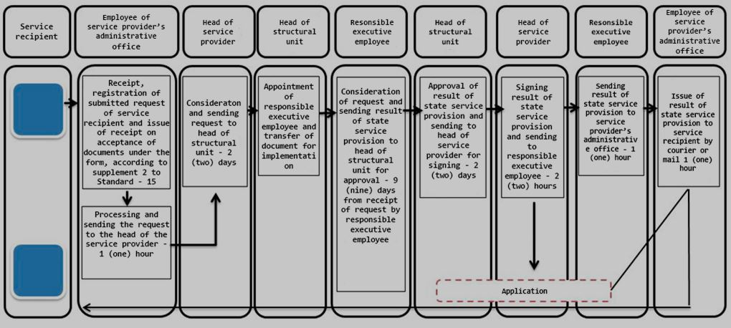

|  |  |
| --- | --- |
|  | - start or end of the state service provision; |
|  | - name of the procedure (action) of the service recipient and (or) structural units (employees) of the service provider; |
|  | - transfer to the next procedure (action); |
|  | - result of state service provision |

© 2012. «Institute of legislation and legal information of the Republic of Kazakhstan» of the Ministry of Justice of the Republic of Kazakhstan