On approval of the Tariff Calculation Methodology with account of stimulating tariff setting methods
Invalidated
Unofficial translation
Order of the Minister of National Economy of the Republic of Kazakhstan of December 28, 2017 No. 436. Registered with the Ministry of Justice of the Republic of Kazakhstan on January 11, 2018 No. 16212. Abolished by order of the Minister of National Economy of the Republic of Kazakhstan dated May 22, 2020 No. 42.
Unofficial translation
Footnote. Abolished by order of the Minister of National Economy of the Republic of Kazakhstan dated May 22, 2020 No. 42 (shall be enforced upon expiry of ten calendar days after the day of its first official publication).
In accordance with subparagraph 4-9) of Article 13 of the Law of the Republic of Kazakhstan “On Natural Monopolies” as of July 9, 1998, I hereby ORDER:
1. To approve the appended Tariff Calculation Methodology.
2. In accordance with the procedure established by the legislation of the Republic of Kazakhstan, the Committee on Regulation of Natural Monopolies, Protection of Competition and Consumer Rights of the Ministry of National Economy of the Republic of Kazakhstan shall:
1) ensure state registration of this order by the Ministry of Justice of the Republic of Kazakhstan;
2) within ten calendar days of the state registration of this order, send its Kazakh and Russian hard and soft copies to the Republican state enterprise with the right of economic management “Republican Center of Legal Information” for its official publication and addition to the Reference control bank of regulatory legal acts of the Republic of Kazakhstan;
3) place this order on the Internet resource of the Ministry of National Economy of the Republic of Kazakhstan;
4) within ten working days of the state registration of this order by the Ministry of Justice of the Republic of Kazakhstan, submit information on the implementation of measures, provided for in subparagraphs 1), 2) and 3) of this paragraph, to the Legal Department of the Ministry of National Economy of the Republic of Kazakhstan.
3. Control over execution of this order shall be entrusted to the supervising vice-minister of national economy of the Republic of Kazakhstan.
4. This order takes effect on January 1, 2018 and is subject to official publication.
Minister of National Economy of
the Republic of Kazakhstan | T.Suleimenov
Approved by
order № 436 as of
December 28, 2017 of
the Minister of National Economy
of the Republic of Kazakhstan
The tariff calculation methodology with account of stimulating tariff setting methods Chapter 1. General provisions
1. This tariff calculation methodology with account of stimulating tariff setting methods (hereinafter referred to as the Methodology) was developed in accordance with subparagraph 4-9) of Article 13 of the Law of the Republic of Kazakhstan “On Natural Monopolies” as of July 9, 1998 (hereinafter referred to as the Law).
2. The stimulating tariff setting method is applied to the entities in case of:
1) expiration of the validity of threshold levels for tariffs, approved in accordance with the Rules for approving the threshold level for tariffs (prices, charge rates) and tariff estimates for regulated services (goods, works) of natural monopolies entities, approved by order №213-ОD of the Chairman of the Agency of the Republic of Kazakhstan for Regulation of Natural Monopolies as of July 17, 2013 (registered in the Register of state registration of regulatory legal acts as №8625);
2) presence of two or more entities (if it is possible to make their comparative analysis) in the regulated market of one industry;
2. economic and technological readiness of natural monopoly entities to apply the stimulating method of tariff regulation.
3. For the purposes of this Methodology, the following concepts are used:
1) individual X-factor - an entity performance indicator, characterizing the ratio of the entity’s expenses for providing a regulated service to the minimum expenses for providing a regulated service given the same or worse structural parameters;
2) the competent authority - a state body in charge of a relevant branch (field) of state administration;
3) structural parameters - quantitative indicators of the entity, significantly affecting the efficiency of the entity’s activity and expenses, the list of which, for the purposes of assessing individual X-factors, is given specifically for each regulated service;
4) regulated services - services (goods, works) provided by a natural monopoly entity and subject to state regulation by the authorized body, including cases of providing services (goods, works) in the form of transfer of a certain product to a consumer;
5) sectoral X-factor - an industry efficiency indicator characterizing the growth rate of the factor productivity of an industry in relation to the factor productivity of the economy, in order to take it into account in the formula for calculating the tariff for the regulated service of a natural monopoly entity, belonging to a relevant industry in accordance with the Methodology;
6) factor productivity of an industry - the industry productivity achieved through effective use of available (without additional expansion) factors of production (labor, capital), the growth rate of which is assessed in accordance with paragraph 30 of the Methodology;
7) standard deviation - a statistical value characterizing the variation of data in relation to the average value, determined by the department of the authorized body or its territorial unit according to the Methodology;
8) a natural monopoly entity (hereinafter referred to as the entity) - an individual entrepreneur or a legal entity engaged in the production of goods, performance of works and (or) rendering of services to consumers under natural monopoly conditions;
9) the stimulating tariff setting method - the method of calculating a tariff for the entity’s regulated service, providing for the setting of a tariff based on the improvement of the entity’s efficiency and compliance with the quality standards of the regulated service;
10) the authorized body - a state body in charge of natural monopolies;
11) the department of the authorized body – a department of the state body in charge of natural monopolies;
12) factor productivity of the economy - the productivity of the economy achieved by using available (without additional expansion) factors of production (labor, capital), the growth rate of which is assessed in accordance with paragraph 32 of the Methodology.
Chapter 2. The setting of a tariff for the entity’s regulated service with account of stimulating
methods of tariff setting
4. The setting of a tariff for the entity’s regulated service with account of stimulating methods of tariff setting (hereinafter referred to as the tariff) includes the following steps:
1) general provisions;
2) sectoral Х-factor’s calculation;
3) making a list of structural parameters used to assess individual X-factor for each entity;
4) making a list (lists) of similar entities and (or) their groups;
5) assessment of individual X-factors;
6) analysis of reliability of expenses for providing a regulated service declared by the entity for tariff calculation;
7) profit calculation;
8) calculation of the entity’s tariff;
9) the system for monitoring and overseeing the achievement of performance indicators and quality standards of regulated services, also depending on the investment program;
10) the calculation of bonuses/fines (penalties) for compliance/non-compliance with the quality standards of regulated services along with identification of the source of payment, the mechanism of imposing fines (penalties).
Clause 1. General provisions
5. The first time the department of the authorized body begins to assess sectoral and individual X-factors for natural monopolies of a particular industry on its own (regardless of its receipt of the entity’s application for approval of the tariff for a regulated service), or if the validity period of approved X-factors ends less than in 180 (one hundred and eighty) calendar days.
6. The department of the authorized body publishes, on its Internet site, a press release about the commencement of work on the development of sectoral and individual X-factors that are taken into account in the formula for calculating tariffs for regulated services of natural monopoly entities of a particular industry.
8. The department of the authorized body, 30 (thirty) calendar days before the expiry of the validity period of earlier approved sectoral and individual X-factors, approves new sectoral and individual X-factors, taken into account in the tariffs for regulated services of natural monopoly entities of a particular industry, for the period of validity of 5 (five) years according to the forms in Appendices 1 and 2 to the Methodology, respectively, broken down by industries, which the department of the authorized body places on its Internet resource.
9. The validity period of the sectoral X-factor for 5 (five) full calendar years begins:
on the date, on which the validity period of earlier approved sectoral X-factor (if any) is over;
on the date approved by the department of the authorized body.
10. For each industry, the department of the authorized body approves a uniform sectoral X-factor for each year of its validity period, which is taken into account in the tariffs for all regulated services related to the natural monopolies of this industry in accordance with the list of entities’ regulated services, approved by order №186 of the Minister of National Economy of the Republic Kazakhstan as of December 30, 2014 (registered in the Register of state registration of regulatory legal acts as №10469).
11. A reason requiring to commence the work on setting the entity’s tariff is the receipt of the entity’s application for approval of the tariff with account of the stimulating tariff setting method (hereinafter referred to as the application) by the department of the authorized body or its territorial unit 180 (one hundred and eighty) calendar days before its introduction.
12. The entity attaches the following information to the application:
information on historical (actual) and estimated expenses for rendering a regulated service is provided in the form of individual X-factors taken into account in the formula for calculating tariffs for a regulated service separately for each entity, according to Appendix 2 to the Methodology for each year of the validity period of the tariff, declared by the entity, which was set in accordance with the Special Procedure for costing used in the approval of tariffs (prices, charge rates) for regulated services (goods, works) of natural monopoly entities, approved by order № 130-OD of the Chairman of the Agency of the Republic of Kazakhstan for Regulation of Natural Monopolies as of April 25, 2013 (registered in the Register of state registration of regulatory legal acts as №8480) (hereinafter referred to as the Special Procedure), with no regard for indicators of socio-economic development of the Republic of Kazakhstan (inflation);
a draft investment program (project) for a period of five or more years, or a document confirming the existence of an approved investment program (project), with the indication of the number and date of the decision made;
calculation of the profit rate on the regulated base of the assets involved;
calculation of depreciation deductions for fixed assets that were used before the implementation of the investment program (project) and are to be put into operation during the implementation of the investment program (project) within a long-term period on a year-by-year basis;
documents confirming the planned volume of regulated services;
the entity’s service quality standard approved by the department of the authorized body in accordance with the Methodology for the formation of standards and assessment of quality of regulated services of natural monopoly entities in a relevant industry (area), approved by order №435 of the Minister of National Economy of the Republic of Kazakhstan as of December 28, 2017 (registered in the Register of state registration of regulatory legal acts as № 16211) (hereinafter referred to as the Standards Methodology).
13. Upon receipt of the application, the department of the authorized body within 7 (seven) calendar days of the date of receipt of such an application:
sets up a working group for calculating the tariff for the entity’s regulated service (hereinafter referred to as the Working Group);
places a press release about the start of work on the calculation of the tariff for the entity’s regulated service on its Internet resource.
14. The head of the department of the authorized body sets up the Working Group consisting of at least 9 (nine) people, by his/her order.
15. The formula for calculating the tariff for the entity’s regulated service takes into account sectoral and individual X-factors for the tariff validity period declared by the entity.
16. When calculating the tariff for the entity’s regulated service, the following sources of information are used:
1) information received from the entities;
2) data of the monitoring of entities’ compliance with service quality standards;
3) information received from the competent authorities;
4) information received from the state body in charge of the state statistical activity;
5) information received from the entities and accredited associations of private entrepreneurs under the authorized body;
6) other sources of information.
17. When calculating the tariff for the entity’s regulated service, the department of the authorized body or its territorial unit divides expenses for its rendering into manageable and unmanageable ones.
18. Unmanageable expenses include such expenses as:
1) material expenses for the purchase of strategic goods, the list of which is determined by the legislation on natural monopolies;
2) depreciation deductions of fixed assets and intangible assets;
3) expenses for compulsory types of insurance, taxes, fees and payments determined in accordance with the legislation of the Republic of Kazakhstan;
4) expenses associated with the level of normative technical losses, in accordance with the calculations of technical losses incurred on the basis of model norms and standards applicable in a relevant industry (area).
19. Manageable expenses of the entity include expenses for the provision of a regulated service, those not belonging to unmanageable ones and taken into account in the tariff in accordance with the Special Procedure.
Historical manageable expenses include the entity’s actual expenses for a five-year period preceding the submission of the entity’s application, according to the report on the execution of tariff estimates.
20. The entity’s application for approval of the tariff for the regulated service is considered by the department of the authorized body or its territorial unit within 180 (one hundred and eighty) calendar days of the date of its submission by the entity, in accordance with the Methodology.
21. If additional information is needed to approve the tariff for the regulated service, the department of the authorized body or its territorial division requests it from the entity in writing, setting the deadline for its submission, which shall be at least 5 (five) working days.
22. The department of the authorized body or its territorial unit, prior to approval of the tariff for the entity’s regulated service, submits its draft for public hearings conducted by the department of the authorized body or its territorial unit in accordance with the Rules for holding public hearings when considering applications for approval of tariffs (prices, charge rates) or their threshold levels for regulated services (goods, works) of natural monopolies in the field of electrical energy industry, approved by order № 219 of the Minister of National Economy of the Republic of Kazakhstan as of March 17, 2015 (registered in the Register of state registration of regulatory legal acts as № 10742).
23. Based on the results of the discussion at public hearings, the department of the authorized body or its territorial unit makes a decision to approve the tariff for the entity’s regulated service, indicating the period of its validity.
24. The order to approve the tariff for the entity’s regulated service:
is signed by the head of the department of the authorized body or its territorial unit;
is sent by the department of the authorized body or its territorial unit to the entity within 35 (thirty-five) calendar days prior to the tariff’s introduction.
25. The department of the authorized body or its territorial unit establishes the period of validity of the tariff for the entity’s regulated service in accordance with the entity’s application for the tariff approval.
26. The tariff for the entity’s regulated service is introduced on the first day of a month following 35 (thirty-five) calendar days after its approval.
27. The entity informs consumers on the introduction of the tariff for its regulated service approved by the department of the authorized body or its territorial unit, within 30 (thirty) calendar days before its introduction by placing this information on its Internet resource (if any) and in the media, distributed in the territory of the administrative-territorial unit, in which the entity operates.
Clause 2. Calculation of Х-factor
28. The department of the authorized body assesses sectoral X-factor within 40 (forty) calendar days of the date of publication of a press release about the commencement of its work on the calculation of sectoral X-factor, which is taken into account in the formula for calculating tariffs for regulated services of areas of natural monopolies in accordance with Appendix 3 to the Methodology.
29. The sectoral X-factor for each year of its validity period is determined using the following formula:

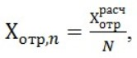

where:

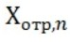

– sectoral Х-factor for each year;

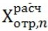

– estimated sectoral X-factor, calculated in accordance with paragraph 30 of the Methodology;
N – the number of years in the validity period of sectoral X-factor.
30. The estimated sectoral X-factor is determined using the Tornqvist index, by calculating the arithmetic average (for 5 (five) years preceding the sectoral X-factor’s development) growth of the factor productivity of the industry in relation to the growth of the factor productivity of the economy using the formula:

where:

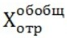

– estimated sectoral Х-factor;

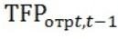

– growth rate of factor productivity of the industry for year t to year t-1, in %, calculated in accordance with paragraph 31 of the Methodology;

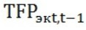

– the growth rate of the factor productivity of the economy for year t to year t-1, in %, calculated in accordance with paragraph 33 of the Methodology;

– year of development of sectoral X-factor;
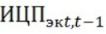
– price index for the purchase of industrial and technical products, characterizing the change in prices for material and technical resources acquired by enterprises of the Republic of Kazakhstan for manufacturing process, for year t to year t-1, determined according to the data provided by the Statistics Committee of the Ministry of National Economy of the Republic of Kazakhstan (hereinafter referred to as the SC), in %. In case the SC has no such data, the department uses the price index for the purchase of industrial and technical products, which characterizes the change in prices for material and technical resources acquired by industrial enterprises of the Republic of Kazakhstan for manufacturing process, for year t to year t-1, determined according to the SC data, in %.
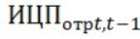
– price index for the purchase of industrial and technical products, characterizing the change in prices for material and technical resources acquired by entities of a relevant industry of the Republic of Kazakhstan for manufacturing process, for year t to year t-1, determined according to the SC data, in %, in case the SC has no such data, the department uses the arithmetic average growth rate of production and investment expenses of entities providing regulated services in the areas of natural monopolies of the relevant industry, for year t to year t-1, in %, calculated using the formula:
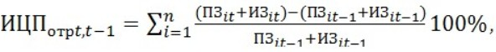

where:

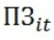
– production expenses of entity i in year t for the provision of regulated services in the areas of natural monopolies of the relevant industry, determined on the basis of the annual report on expenses, income and tariffs for regulated services of entity i;
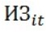
– investment expenses of entity i in year t, taken into account in the investment program approved by the department, for the provision of regulated services in the areas of natural monopolies of the relevant industry, determined on the basis of the annual report on expenses, income and tariffs for regulated services of entity i;
n – the number of entities that provide regulated services in the areas of natural monopolies of the relevant industry.
31. The growth rate of the factor productivity of the industry for year t to year t-1 is calculated using the formula:

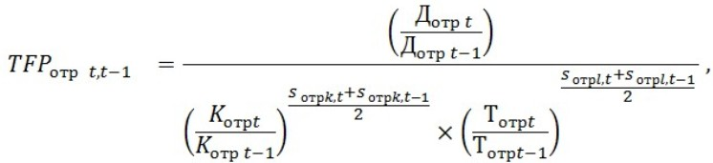

where:

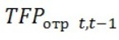
– the growth rate of factor productivity of the industry for year t to year t-1;
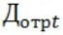
– real (in real terms, adjusted by leveling inflationary effects, that is, expressed in constant prices (hereinafter referred to as real) gross domestic product (GDP) of the industry in year t, in thousand tenge, determined using the following formula:
where:

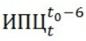
- the consumer price index for year t by December of year t0 - 6 according to the SC data, in %. Given the SC data, the index can be taken in constant prices of any other year.
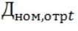
– the industry’s GDP in current prices in year t, in thousand tenge, determined according to the SC data. If the SC has no data on the GDP of the industry in year t, the department uses the amount of income in year t of the entities providing regulated services in the areas of natural monopolies of the relevant industry:
where:

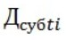
– income in year t of entity i providing regulated services in the areas of natural monopolies of the relevant industry, thousand tenge;
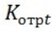
– the real value of fixed assets in the industry in year t, determined using the following formula:
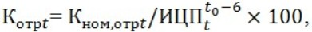

where:

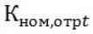
– the value of fixed assets in the industry in current prices in year t, in thousand tenge, determined according to the SC data. If the SC has no data on the value of fixed assets in the industry, the department uses the amount of the value of fixed assets in year t of the entities providing regulated services in the areas of natural monopolies of the relevant industry:
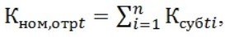

where:

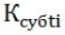
– the value of fixed assets in year t of entity i providing regulated services in the areas of natural monopolies of the relevant industry, thousand tenge;
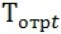
– the number of hours worked per person in the relevant industry in year t, in hours/person, determined according to the SC data;
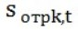
– the share of expenses for the acquisition of fixed assets in the total amount of income of the industry in year t, determined using the following formula:
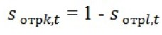
– the share of labor expenses in the total amount of income of the industry in year t, determined using the following formula:
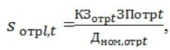

where:

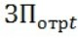
– the average annual salary in the industry in year t, determined according to the SC data, in tenge/person;
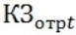
– the number of people employed in the industry in year t, determined according to the SC data, thousand people.
32. For simplification purposes, the growth rate of the factor productivity of the industry for year t to year t-1 is assessed by the department of the authorized body in the log-linear form using the formula:

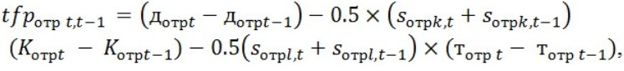

where:

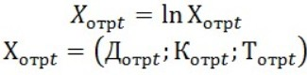

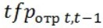
– assessment of the growth rate of the factor productivity of the industry for year t to year t-1.
33. The growth rate of the factor productivity of the economy for year t to year t-1 is calculated using the formula:

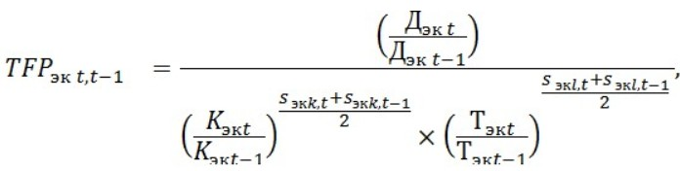

where:

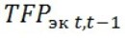
– the growth rate of the factor productivity of the economy for year t to year t-1;
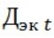
– real GDP of the economy in year t, in thousand tenge, determined using the following formula:
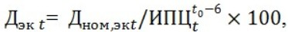

where:

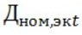
– GDP of the economy in current prices in year t, in thousand tenge, determined according to the SC data.
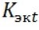
– the real value of fixed assets in the economy in year t, determined using the following formula:
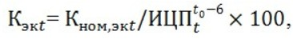

where:

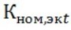
– the value of fixed assets in the economy in current prices in year t, in thousand tenge, determined according to the SC data;
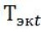
– the number of hours worked per person in the economy in year t, in hours/person, determined according to the SC data;
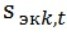
– the share of expenses for the acquisition of fixed assets in the total amount of income of the economy in year t, determined using the following formula:
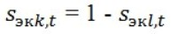

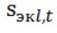
– the share of labor expenses in the total income of the economy in year t, determined using the following formula:
where:

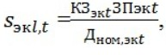

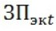
– the average annual salary in the economy in year t, determined according to the SC data, in tenge/person;
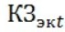
– the number of people employed in the economy in year t, determined according to the SC data, in thousand people.
34. For simplification purposes, the growth rate of the factor productivity of the industry for year t to year t-1 is assessed by the department of the authorized body in the log-linear form:
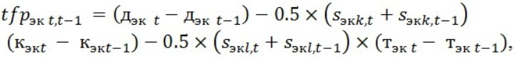

where:

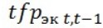
– assessment of the growth rate of the factor productivity of the economy for year t to year t-1.
Clause 3. Making the list of structural parameters used to assess individual
X-factor for each entity
35. For the purposes of calculating individual X-factors, the department of the authorized body, within 40 (forty) calendar days of the date of publication of a press release about the commencement of their development, draws up a draft list of structural parameters for this regulated service.
36. The department of the authorized body sends the preliminary list of structural parameters used to assess individual X-factors (hereinafter referred to as the preliminary list of structural parameters), which includes the minimal list of structural parameters used to assess individual X-factors for the following regulated services in accordance with the form in Appendix 4 to the Methodology.
37. The department of the authorized body adds (removes) structural parameters to (from) the draft preliminary list.
38. The department of the authorized body, in accordance with the State register of natural monopoly entities, makes a list of entities providing one and the same regulated service, for which individual X-factors are calculated (hereinafter referred to as the list of entities).
39. The department of the authorized body, within 7 (seven) calendar days of the date of publication of the press release about the beginning of the calculation of individual X-factors, sends to the entities providing the regulated service a request to submit annual historical data on structural parameters for their use in the assessment of individual X-factors taken into account in the formula for calculating tariffs for the regulated service in accordance with the form in Appendix 5 to the Methodology. The entities produce annual historical data on structural parameters for the period of rendering the regulated service, prior to the commencement of the development of individual X-factors.
40. When forming the values of structural parameters, the entity uses the following sources of information:
1) equipment certificates;
2) certificates of the state acceptance commission and (or) certificates of facility commissioning (putting into operation);
41. The entity shall, within fourteen (14) calendar days of the date of receipt of the draft preliminary list of structural parameters, submit the requested information to the department of the authorized body.
42. The entity providing the regulated service has the right to submit to the department of the authorized body its proposals on adding and (or) removing any structural parameters to (from) the draft preliminary list.
43. If case of receiving proposals on adding new structural parameters to the draft preliminary list from the entities, the department of the authorized body arranges for additional collection of values on all the structural parameters proposed by the entities from all the entities providing the relevant regulated service.
If over 10% (ten percent) of the entities do not have any structural parameter, this structural parameter is not included in the final list.
44. The department of the authorized body makes the initial list of structural parameters, which includes:
1) structural parameters from the draft preliminary list, except for those offered for removal by more than 50% (fifty percent) of the entities;
2) structural parameters proposed by the entities (if any);
3) the preliminary list includes at least three structural parameters, but not more than ten ones.
45. After conducting the analysis, the department of the authorized body distinguishes statistically significant structural parameters from the preliminary list of structural parameters.
46. The set of values of each structural parameter s from the preliminary list, received from all the entities providing a certain regulated service, is formed as a matrix:
where:

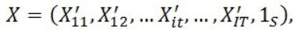

X – the matrix of logarithmic (by the natural logarithm) values ​​of structural parameters;

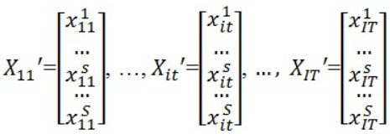

– the logarithmic value of structural parameter s for year t according to the data of entity i;

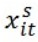

– the entity identifier, I - the number of entities providing the regulated service;

– the year identifier, T - the shortest period of provision of the regulated service across all the entities, preceding the development of individual X-factors, 1 - the first year of this period;

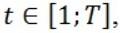

– the structural parameter identifier, S - the number of structural parameters;

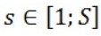

– unit vector of dimension S.
The matrix of the sum total of the entity’s manageable expenses for the provision of a regulated service:

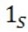

where:
Y – the matrix of logarithmic real manageable expenses for the provision of a regulated service;

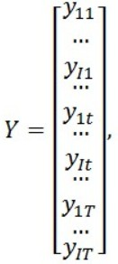

Y– the amount of logarithmic real manageable expenses for the provision of a regulated service for year t according to the data of entity i, obtained by multiplying nominal manageable expenses for year t by

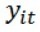

47. In order to assess the statistical significance of structural parameters in the regression analysis, the department of the authorized body:

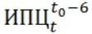

from regression (relationship between manageable expenses of entities providing the regulated service, (Y) and structural parameters (X))
where:

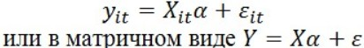

- the statistical indicator “error of regression estimate” for entity i in year t, with the expected value equal to zero and the same variance;

- the vector of regression coefficients, determining the relationship of manageable expenses Y with each structural parameter Xs by the method of least squares calculates the values of the following statistical indicators:

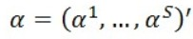

the estimate of the regression coefficient vector
broken down by structural parameters using the following formula:

standard deviations for the vector of regression coefficients

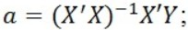

broken down by structural parameters using the following formula:

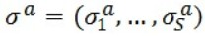

the t-criteria (Student’s t-test) for each regression coefficient using the following formula:

coefficient of determination R² according to the following formula:

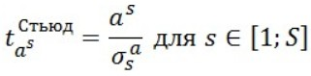

F-criterion (Fisher criterion) according to the following formula:

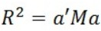

identifies statistically insignificant structural parameters, the absolute values ​​of t-criteria for the regression coefficients of which observe the following condition:

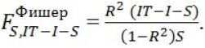

where:

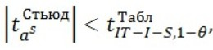

- tabular value of t-criterion (Student’s t-test);

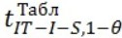

- the probability (Student’s criterion), with which a structural parameter is recognized as statistically insignificant, is determined by the department of the authorized body at the level of 90%;

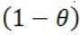

in case of presence of insignificant structural parameters, excludes from the regression, indicated in this paragraph of the Methodology, the data of one of them for all entities I for the entire period T, i.e.

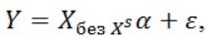

where:

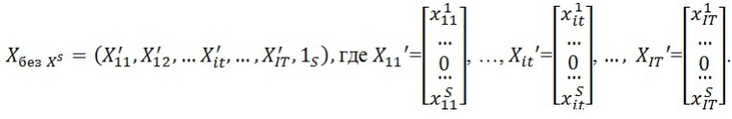

and identifies statistically insignificant structural parameters for this regression in accordance with the algorithm provided for in subparagraphs 1) 3) of this paragraph of the Methodology;
in case of absence of statistically insignificant structural parameters in the regression, estimates the F-criterion (Fisher criterion) in accordance with the following condition:

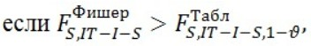

where:

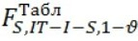

- the tabular value of the F-criterion (Fisher criterion) given in Table 1 to the Methodology, with degrees of freedom S and IT-I-S;

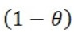

- probability (Fisher criterion), with which the structural parameter is recognized as statistically insignificant, is determined by the department of the authorized body at the level of 95%;
then the regression is recognized as statistically significant and all the structural parameters of this regression are statistically significant and are used in further analysis of assessment of individual X-factors, including the choice of similar entities;

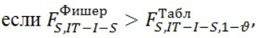

then the regression sequentially (one after another) excludes the data of all structural parameters for all entities I for period T and the steps indicated in this paragraph of the Methodology are carried out.
48. If the exclusion of the data of all structural parameters from the regression failed to identify statistically significant structural parameters, the structural parameters of the regression with the highest F-criterion are recognized as statistically significant and used in further analysis of assessment of individual X-factors.
49. Taking into account the results of calculation of the significance of structural parameters from the preliminary list of structural parameters, the department of the authorized body draws up a draft final list of structural parameters and presents it for consideration by the Working Group on the calculation of individual X-factors. The significance of the structural parameters for their use in identifying groups of similar entities and calculating individual X-factors according to the form in Appendix 6 to the Methodology is presented for consideration by the Working Group.
50. Having considered the draft final list of structural parameters, the Working Group on the calculation of individual X-factors, within 7 (seven) calendar days of the date of its receipt, makes a decision either:
to approve the draft final list of structural parameters formed by the department of the authorized body; or
to approve the draft final list of structural parameters adjusted by the proposals of members of the Working Group on the calculation of individual X-factors by removing or retaining the structural parameters from (in) the preliminary list.
51. If the Working Group on the calculation of individual X-factors decides to approve the (adjusted) draft final list of structural parameters, within 5 (five) calendar days of the date of its receipt, the department of the authorized body places the list of structural parameters used to assess individual X- factors taken into account in the formula for calculating tariffs for the regulated service, according to the form in Appendix 7 to the Methodology, on its Internet resource.
52. The duration of the historical period of validity of approved structural parameters used in the calculation of individual X-factors is same as that of the period of validity of newly approved individual X-factors.
Clause 4. Making the list (lists) of similar entities and (or) their groups
53. In order to assess individual X-factors taken into account when calculating tariffs for a regulated service, the department of the authorized body, within 30 (thirty) calendar days of the date of publication of the list of structural parameters, forms groups of similar entities providing this regulated service, whose data are used to assess individual X-factors taken into account in the calculation of tariffs for the provision of a regulated service (hereinafter referred to as groups of similar entities).
54. In order to form groups of similar entities, the department of the authorized body carries out a statistical analysis of similarity of entities providing a regulated service.
55. The values of structural parameters from the approved list are as follows:

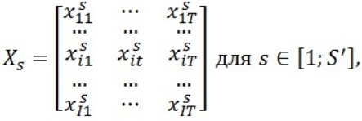

where:
X - the matrix of logarithmic (by the natural logarithm) values of structural parameters from the approved list;
i∈ [1;I] - the entity identifier, I - the number of entities providing the regulated service;
t∈ [1;T] - the year identifier, T - the shortest period of rendering the regulated service across all entities, preceding the development of individual X-factors, 1 - the first year of this period;

- the number of structural parameters in the approved list.
Real manageable expenses for the provision of the regulated service:

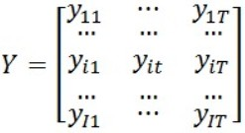

where:
Y - the matrix of logarithmic real manageable expenses for the provision of the regulated service;
If some entity i has no data on manageable expenses and (or) one or more structural parameters for the entire period T, this entity i is excluded from the analysis, in further reports on the similarity and calculation of individual X-factors, such entity is marked as “excluded due to lack of data”.
56. As part of a statistical analysis of comparability of the analyzed data of entities, the department of the authorized body:
from regression (relationship between manageable expenses of entities providing the regulated service, (Y) and structural parameters (X), approved for assessing individual X-factors)

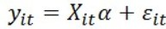

where

– the statistical indicator “error of regression estimate” for entity i in year t, with a mathematical expectation equal to zero and the same variance;

- the vector of regression coefficients that determine the relationship of manageable expenses Y with each structural parameter Xs;
the method of least squares calculates the values of estimates of the vector of regression coefficients
by structural parameters approved for the assessment of individual X-factors using the following formula:

using the model coefficients for each entity i and year t assessed in accordance with this paragraph of the Methodology, calculates estimated balances using the formula below:

or in the matrix form e = Y - Xa.
where:
e^{est} – estimated balances using the model coefficients for each entity i and year t, assessed in accordance with this paragraph of the Methodology;
X - the matrix of logarithmic (by the natural logarithm) values of structural parameters;
Y - the matrix of logarithmic real manageable expenses for the provision of a regulated service;
i∈ [1;I] - the entity identifier, I - the number of entities providing the regulated service;
t∈ [1; T] - the year identifier, T - the shortest period of provision of the regulated service across all entities, preceding the development of individual X-factors, 1 - the first year of this period;
for each entity I, calculates the arithmetic average of balances year-wise:

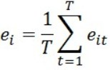

chooses the smallest balance from the values of all entities, adds it to the estimated manageable expenses — obtains the estimated balances:

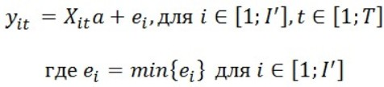

generates a series of values ​​for all entities in ascending order and calculates the frequency (number of values), with which each value W is in the series, in %, and cumulative frequency, in %;
calculates 25%-percentile

using the formula below:

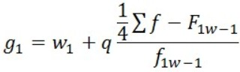

where:

– a series of values for all entities in ascending order;
W₁ ₋ the lower limit of the interval containing 25%-percentile (the interval is determined by the cumulative frequency, the first one exceeding 10%);
F_{1W-1} - the cumulative frequency of the interval preceding the interval containing 25%-percentile;
f_{1W-1} - the frequency of the interval containing 25%-percentile;
if the difference between the maximum and minimum values in the interval containing 25%-percentile, 25%-delta is:
less than or equal to 0.5, all other groups of similar entities are formed on the basis of this difference - all entities, whose values are in the next ascending interval, the difference between the maximum and minimum values in which is 25%-delta, are formed into one group;
greater than 0.5, the first group is taken by entities, the maximum and minimum values of which differ by 0.5, subsequent groups are formed on the basis of 0.5: all entities, whose values are in the next ascending interval, the difference between the maximum and minimum values in which is 0.5, are formed into one group.
57. According to the results of statistical analysis of the entities’ similarity, the department of the authorized body forms a project of groups of similar entities.
58. The department of the authorized body presents the project of groups of similar entities for the consideration by the Working Group on the calculation of individual X-factors along with the results of statistical analysis of the entities’ similarity according to the form in Appendix 8 to the Methodology. The department publishes the minutes, the list, the names of the entities and the decision of the Working Group on its Internet resource and the list of groups of similar entities approved by the Working Group.
59. Having considered the project of groups of similar entities, within 7 (seven) calendar days of the date of its receipt, the Working Group on the calculation of individual X-factors makes a decision either:
to approve the project of groups of similar entities, formed by the department of the authorized body; or
to approve the project of groups of similar entities, adjusted by proposals of the members of the Working Group on the calculation of individual X-factors.
60. If the Working Group on the calculation of individual X-factors makes a decision to approve the (adjusted) project of groups of similar entities, within 5 (five) calendar days of the date of its adoption:
by his/her order, the head of the department of the authorized body approves the list of groups of similar entities providing the regulated service, whose data are used to assess individual X-factors according to the form in Appendix 9 to the Methodology;
the department of the authorized body places an order to approve groups of similar entities on its Internet resource.
If the Working Group on the calculation of individual X-factors fails to come to a consolidated opinion, the decision is made by the leadership of the department of the authorized body.
All decisions of the Working Group on the calculation of individual X-factors are recorded in the minutes of meetings and posted on the Internet resource of the department of the authorized body.
Clause 5. Calculation of individual X-factors
61. The department of the authorized body, within 10 (ten) calendar days of the date of publication of the list of groups of similar entities:
calculates individual X-factors specifically for each entity;
presents an opinion on the results of calculation of individual X-factors, in accordance with the form in Appendix 11 to the Methodology, for the consideration by the Working Group.
62. Individual X-factors specifically for each entity for each year of its validity period are determined using the following formula:

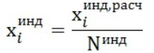

where:

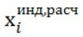

– estimated individual X-factor calculated for entity i in accordance with paragraph 50 of the Methodology;

– the number of years in the period of validity of individual X-factors.
63. The department of the authorized body calculates the estimated individual X-factors for each entity i as the arithmetic average of the time deviation of actual expenses from the efficient frontier using the following formula:

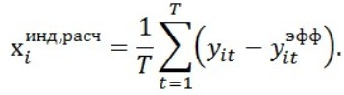

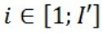

– the entity identifier, I’- the number of entities from the approved list of similar entities providing the regulated service.
64. In order to assess individual X-factors, the department of the authorized body, using the method of least squares, assesses minimum manageable expenses for the provision of a regulated service as a function of structural parameters (hereinafter referred to as the efficient frontier) in accordance with the following algorithm:
the set of values ​​of structural parameters from the approved list according to the data of entities from the approved list of similar entities providing the regulated service is formed as a matrix:

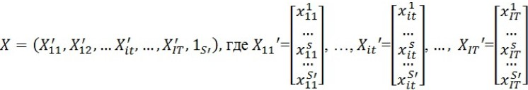

where:
X - the matrix of logarithmic (by the natural logarithm) values ​​of structural parameters from the approved list;

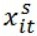

– the logarithmic value of structural parameter s from the approved list for year t according to the data of entity i;

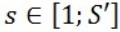

– identifier of the structural parameter, S’- the number of structural parameters from the approved list;

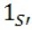

– unit vector of dimension S’.
the sum total of manageable expenses for the provision of a regulated service according to the data of entities from the approved list of similar entities is presented in the form of a matrix:

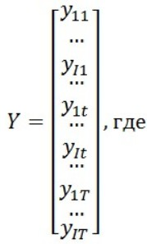

where:
Y - a matrix of logarithmic real manageable expenses for the provision of a regulated service.
from regression (relationship between manageable expenses of entities providing the regulated service, (Y) and structural parameters (X))

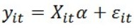

or in matrix form Y = X a +

where:

- the statistical indicator “error of regression estimate” for entity i in year t, with a mathematical expectation equal to zero and the same variance;

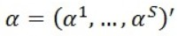

- vector of regression coefficients, determining the relationship of manageable expenses Y with each structural parameter Х_{s}
using the method of least squares, calculates the values ​​of the following statistical indicators for assessing the vector of regression coefficients a = (a¹, ..., a^{s})' broken down by structural parameters using the following formula:

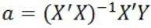

using the model coefficients estimated in accordance with this paragraph of the Methodology for each entity i and year t, estimated balances are calculated using the following formula:

or in the matrix form e = Y - Xa.
where:
e ^{est} - estimated balances using the model coefficients for each entity i and year t, calculated in accordance with this paragraph of the Methodology;
for each entity i calculates the arithmetic average for each year of balances:

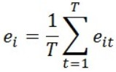

chooses the smallest balance by the values of all entities, adds it to the estimated manageable expenses (the shift of the efficient frontier to the most efficient entity) - the obtained calculated manageable expenses are the efficient frontier:

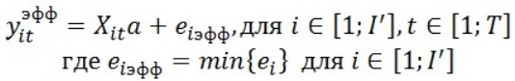

65. The Working Group on the calculation of individual X-factors, having considered the opinion of the department of the authorized body on the results of the calculation of individual X-factors, within 7 (seven) calendar days of the date of its receipt, makes a decision either:
to approve the results of individual X-factors for each specific entity, calculated by the department of the authorized body; or
to approve the sizes of individual X-factors for each specific entity, adjusted according to proposals of the members of the Working Group on the calculation of individual X-factors.
The decision of the Working Group on the calculation of individual X-factors is recorded in the minutes of meetings and placed on the Internet resource of the department of the authorized body.
66. Within (seven) 7 calendar days after the Working Group on the calculation of individual X-factors makes a decision to approve the size of individual X-factors specifically for each entity, individual X-factors, taken into account in the tariffs for the regulated service, are approved by the order of the head of the department of the authorized body.
Clause 6. Analysis of reliability of expenses for the provision of a regulated service, declared
by entities for the tariff calculation
67. Analysis of reliability of expenses for the provision of a regulated service, declared by entities for the calculation of the tariff for a regulated service for the period of its validity declared by the entity (hereinafter referred to as the entity’s expenses) is carried out by the department of the authorized body in 2 (two) stages, within 60 (sixty) calendar days of receipt of the entity’s application for approval of the tariff. At the first stage, the department of the authorized body carries out a statistical analysis of reliability of expenses declared by the entity, at the second one - an expert analysis.
68. For a statistical analysis of reliability of expenses declared by the entity, the department of the authorized body uses the following data on the entity’s expenses (hereinafter referred to as the entity’s historical expenses) for the next period (hereinafter referred to as the historical period):
1) if the entity applied to the department of the authorized body for approval of the tariff for the regulated service with account of stimulating tariff setting methods for the first time, 5 (five) years or the period of rendering the regulated service (if less than 5 (five) years) preceding the entity’s application for the approval of the tariff. The data are taken from the entity’s reports on the execution of tariff estimates.
If the application for approval of the tariff for the regulated service is submitted by the entity before the deadline for submitting the annual report on the execution of tariff estimates, data from the tariff estimates, approved by the department of the authorized body, are used.
2) the validity period of the current tariff with account of the stimulating method (if any). The data are taken from the entity’s annual reports on income, expenses and tariffs for the regulated service.
If the application for approval of the tariff for the regulated service is submitted by the entity before the deadline for submitting the annual report on income, expenses and tariffs, the data, taken into account for its calculation, are used.
69. The entity’s historical expenses are converted into real ones for each item of expenses and for each year according to the following formula:

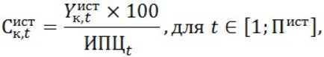

where:
к – item of expenses;

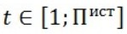

– year identifier, P^{hist} - historical period, 1 - the first year of the historical period;

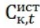

– the amount of real historical expenses of entity in item k for year t, in thousand tenge;

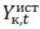

– the amount of historical expenses of entity in item k for year t, in thousand tenge.
70. The entity’s declared expenses are converted into real expenses for each item of expenses and for each year according to the formula:

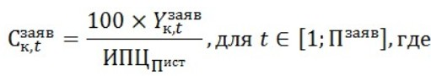

where:
к – item of expenses;

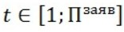

– the year identifier,

– the validity period of the tariff for the regulated service declared by the entity, for the approval of which the entity submitted an application (hereinafter referred to as the declared period of the tariff validity), 1 - the first year of this period;

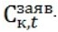

- consumer price index for historical and forecast periods by the first year of the historical period, according to the SC, in %.

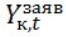

– the amount of actual expenses declared by the entity in item k for year t, in thousand tenge.

– the amount of expenses declared by the entity in item k for year t, in thousand tenge.
71. The reliability of expenses declared by the entity is determined in accordance with the algorithm:
for each line k generates a series of values ​​for all years in ascending order (hereinafter referred to as the k-th row) and calculates the frequency (number of values) with which each value of line k in each year is given in the k-th row, in %, and cumulative frequency, in %;
for each k-th row according to historical data, calculates 99%-percentile

according to the following formula, respectively:

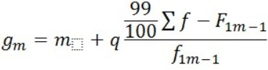

where:
m - the lower limit of an interval with a 99%-percentile (the interval is determined by the cumulative frequency, the first one exceeding 99%);
q - the interval value;
F_{m-1} - the cumulative frequency of an interval preceding the interval with a percentile;
f_{m-1} - the frequency of an interval with a percentile;
draws conclusions about statistical reliability of the amount of expenses of line k in year t declared by entity i in accordance with the following criteria:
if

then the amount of expenses of line k in year t declared by entity i is recognized as statistically reliable;
in all other cases, the amount of line k in year t declared by entity i is recognized as statistically unreliable;
72. The Working Group:
may decide to revise percentiles to determine the statistical reliability of expenses.
makes a conclusion about reliability of expenses of item k declared by the entity in accordance with the following criteria:
if at least for one year

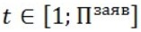

the amount of expenses of item k declared by the entity is recognized as statistically unreliable, the expenses of item k declared by the entity are recognized as statistically unreliable;
if for all

the amount of expenses of item k declared by the entity is recognized as statistically reliable in accordance with subparagraph 2) of this paragraph of the Methodology, the expenses of item k declared by the entity are recognized as statistically reliable.
73. In case of no expenses, the declared amounts for which are recognized as statistically unreliable, the department of the authorized body, within 14 calendar days of the date of receipt of the entity’s application for approval of the tariff:
sends a notification about the absence of statistically unreliable expenses to the entity;
uses the expenses declared by the entity (hereinafter referred to as the expenses recognized as reliable by the department of the authorized body) in further calculations of the tariff for the regulated service.
74. If there are expenses, the declared amounts for which are found to be statistically unreliable, the department of the authorized body, within 14 calendar days of the date of receipt of the entity’s application for approval of the tariff, sends the entity a list of statistically unreliable expenses conducted as part of a statistical analysis, according to form 1 of the list of statistically unreliable expenses of the entity for the provision of a regulated service broken down by items of expenses and form 2 of the calculation carried out as part of a statistical analysis of reliability of the entity’s expenses for the provision of regulated services, in accordance with Appendix 11 to the Methodology.
75. Within 14 (fourteen) calendar days of the date of receipt of the list of statistically unreliable expenses, an entity may submit the following documents confirming these expenses to the department of the authorized body:
reporting documents submitted by the entity to state bodies in accordance with the legislation of the Republic of Kazakhstan on accounting and financial reporting and also on state statistics;
decisions of competition (tender) commissions for the procurement of material, financial resources, equipment and services;
loan agreements (indicating the terms of financing, including the terms of payment of remuneration, commission payments, etc.);
decisions of the state property management body or a state-owned enterprise to fix the fund of wages and official salaries of managers, their deputies, chief (senior) accountants, as well as the system of their bonuses and other remuneration (for state-owned enterprises or enterprises with a predominant state share participation);
protocols of intent, contracts;
other materials.
The entity submits supporting documents along with an explanatory note attached to each document, bound and tied, certified by the seal and signature of the head of the entity or his/her deputy.
76. The department of the authorized body shall, within 14 (fourteen) calendar days of the date of receipt of the supporting documents from the entity, present them for consideration by the Working Group.
The Working Group, within 7 (seven) calendar days of the receipt of the documents for each amount of expenses declared by the entity, recognized unreliable by the results of the statistical analysis, makes one of the following decisions - the amount of expenses of item k, recognized unreliable in year t by the results of the statistical analysis, is reliable in the amount:
declared by the entity;
determined by the Working Group.
The results of consideration of reliability of expenses declared by the entity by the Working Group are approved in the protocol in the format of Form 3, according to Appendix 11.
Clause 7. Calculation of profit
77. The calculation of the profit accounted for in the tariff for the regulated service provides for the setting of an acceptable level of profit required for implementation of the investment program, in accordance with subparagraph 4) of paragraph 2 of Article 15-1 of the Law.
The profit rate is calculated according to the instructions for calculating the profit rate (net income) for (on) the regulated base of involved assets for natural monopoly entities in each area, approved by the department of the authorized body in accordance with the Law.
Clause 8. Calculation of the tariff of the entity
78. The amount of expenses recognized by the Working Group as reliable:
are used by the department of the authorized body in further calculations of the tariff for the regulated service of the entity;
are sent to the entity, within 7 (seven) calendar days of the date of the decision of the Working Group.
Tariff calculations are carried out by the department of the authorized body according to the formula:

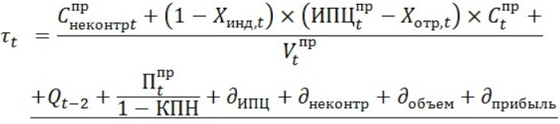

where:

- tariff for the regulated service applied by the entity in year t;

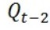

- bonus/penalty for compliance with service quality standards, calculated using the formula:

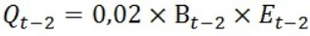

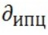

- adjustment for changes in inflation, calculated using the formula:

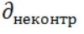

- adjustment for the change in unmanageable expenses, calculated using the formula:

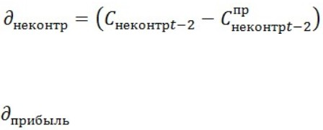

- the adjustment of profit with account of execution of the investment program, calculated using the formula

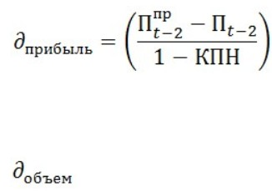

- adjustment for the change in the volume of services rendered, calculated using the formula

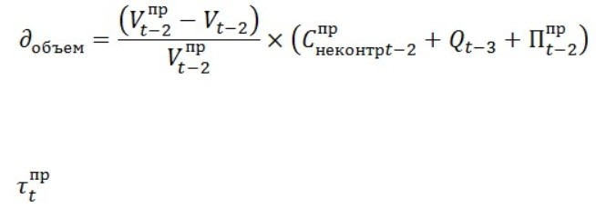

- the tariff for the regulated service for year t according to the data approved by the department of the authorized body for the entity’s use for annual tariff adjustment;

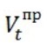

- the volume of the regulated service rendered according to the data approved by the department of the authorized body for the entity’s use for annual tariff adjustment;
V_{t} - the actual volume of the regulated service provided by the entity in year t, determined by the department of the authorized body within the framework of the monitoring of expenses, income and tariffs for the regulated service of the entity;
CIT - corporate income tax rate, in accordance with the current tax legislation of the Republic of Kazakhstan.
E_{t} - the entity’s income from the provision of a regulated service in year t, determined by the department of the authorized body within the framework of the monitoring of expenses, income and tariffs for the entity’s regulated service;

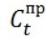

– expenses for year t, unmanageable by the entity, according to the data approved by the department of the authorized body for the entity’s use for annual tariff adjustment, with no regard for inflation for year t;
C_{t} - expenses unmanageable by the entity for the provision of the regulated service in year t, the amount of which is determined by the department of the authorized body within the framework of the monitoring of expenses, income and tariffs for the entity’s regulated service;

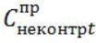

– expenses for year t unmanageable by the entity according to the data approved by the department of the authorized body for the entity’s use for annual tariff adjustment;
C_{unman} - expenses unmanageable by the entity for year t, the amount of which is determined by the department of the authorized body within the framework of the monitoring of expenses, income and tariffs for the regulated service of the entity;

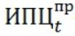

– the consumer price index, determined according to the forecast data of the Ministry of National Economy of the Republic of Kazakhstan for year t, in percentage terms;
CPI_{t} - consumer price index, determined according to the SC data for year t, in percentage terms;
X_{ind,t -} the individual X-factor approved by the department of the authorized body for year t, which is taken into account in the formula for calculating the tariff for the entity’s regulated service;
Х_{sect,t} - the sectoral X-factor approved by the department of the authorized body for year t, taken into account in the formula for calculating tariffs for regulated services related to the areas of natural monopolies of a relevant industry;
B_{t} - the coefficient of the entity’s compliance with the quality standard of the regulated service, determined by the department of the authorized body within the framework of the monitoring of compliance with the quality standard of the regulated service for year t;

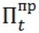

– the entity’s profit margin for year t according to data approved by the department of the authorized body for the entity’s use for annual tariff adjustment, thousand tenge;
P_{t} - the entity’s profit margin for year t, the amount of which is determined by the department of the authorized body within the framework of the monitoring of implementation of the investment program for the entity’s regulated service, thousand tenge.
79. After holding public hearings within 120 (one hundred and twenty) calendar days of the date of receipt of the entity’s application for approval of the tariff, the department of the authorized body approves the tariff for the regulated service, submitted for each year of the tariff validity period, declared by the entity, depending on sectoral and individual X -factors and the entity’s compliance with the quality standard of the regulated service.
80. The tariff for the entity’s regulated service is differentiated in accordance with the Rules for approving tariffs (prices, charge rates) and tariff estimates for regulated services (goods, works) of natural monopoly entities approved by order № 215-ОD of the Chairman of the Agency of the Republic of Kazakhstan for Regulation of Natural Monopolies as of July 19, 2013 (registered in the Register of state registration of regulatory legal acts as № 8642), as well as the Methodology for calculating differentiated tariffs for regulated water supply services and (or) wastewater disposal, approved by order № 297-ОD of the Chairman of the Agency of the Republic of Kazakhstan for Regulation of Natural Monopolies as of October 1, 2013 (registered in the Register of state registration of regulatory legal acts as № 8886).
81. Along with the tariff for the regulated service, the department of the authorized body approves the quality standard of the regulated service, according to the Standards Methodology.
82. Annually, on or before May 1 of a year following the reporting period, the entity submits to the department a report on implementation of the investment program, a report on compliance with the quality standards of the regulated service, as well as reports on income, expenses and tariffs.
The department of the authorized body, pursuant to the consideration of the entity’s reports, on or before September 1 (one) of a relevant year, sends to the entity a notification of the tariff change, taking into account:
the entity’s implementation of the investment program;
changes in unmanageable expenses and the volume of regulated services rendered in the reporting period;
compliance with the quality standards;
the actual consumer price index according to the Statistics Committee of the Ministry of National Economy of the Republic of Kazakhstan.
Clause 9. The system of monitoring and control of implementation of performance indicators
and quality standards of regulated services, also depending on the investment program
83. The department of the authorized body annually adjusts the tariff for a regulated service, approved with account of the stimulating tariff setting method.
To make an adjustment, the entity, on or before May 1 of a year following a reporting one, submits to the department of the authorized body, with regard to the formula, with account of:
a report on the implementation of the investment program, in accordance with the Rules for approving investment programs (projects) of a natural monopoly entity, their adjustment, as well as on the analysis of information on their execution, approved by order № 194 of the Minister of National Economy of the Republic of Kazakhstan as of December 30, 2014 (registered in the Register state registration of regulatory legal acts as № 10459);
a report on income, expenses and tariffs in accordance with the form in Appendix 13 to the Methodology;
a report on the compliance of the entity’s regulated service with the quality standard according to the Standards Methodology. To the report on the compliance of the regulated service with the quality standard, the entity attaches an explanatory note with regard to all indicators about the reasons of non-compliance (if any) of actual values of the indicators achieved by the entity during the reporting period with their target values, adjusted for tolerances from the target values of the indicators for the reporting period (hereinafter referred to as reasons of compliance).
84. The monitoring of the entity’s compliance with the quality standard of the regulated service and calculation of the rate of compliance with the quality standard of the regulated service (B) taken into account when calculating the tariff for the entity’s regulated service is carried out in accordance with the Standards Methodology.
85. The rate of the entity’s compliance with the quality standard of the regulated service is adjusted by the department of the authorized body or its territorial unit, based on the reporting data of the entity by calculating the quality standard compliance rate using the formula:
B = 1– the sum of the values of the compliance rates of indicators of quality standard/number of indicators
Compliance rates for each performance indicator of the quality standard are calculated as the ratio of the actual value to the target value using the formula:

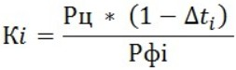

where:
Ki - the rate of compliance of the actual value of indicator i, achieved by the entity during the reporting period, with the allowable value of this indicator for reporting period i);
Р_{ai} - the actual value of indicator i, achieved by the entity during the reporting period;
Р_{t} – the target value of indicator i;

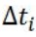

– allowable deviation of the actual value from the target one of indicator i for the reporting period.
Clause 10. Calculation of bonuses/fines (penalties) for compliance/non-compliance with
quality standards of regulated services with identification of the source of payment, the
mechanism of imposing fines (penalties)
86. The bonus/fine (penalty) for compliance/non-compliance with the quality standards of regulated services is calculated using the formula:

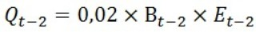

where:
Q_{t-2} - bonus/penalty for compliance with the quality standards of the regulated service;
B_{t-2} - the coefficient of the entity’s compliance with the quality standard of the regulated service, determined by the department of the authorized body within the framework of the monitoring of the regulated service’s compliance with the quality standard based on the results of year t-2;
E_{t-2 -} the entity’s income from rendering the regulated service in year t-2, determined by the department of the authorized body within the framework of the monitoring of expenses, income and tariffs for the entity’s regulated service.
The amount of the bonus/penalty for the regulated service’s compliance/non-compliance with the quality standard for year t-2 is summed up/deducted from the entity’s income taken into account when adjusting the tariff for t-year.
The tariff adjustment for changes in inflation, according to the results of the investment program, changes in unmanageable expenses and the volume of services rendered in the reporting period.
87. The tariff is adjusted for changes in inflation using the formula:

where:

– the tariff adjustment for changes in inflation;

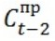

– entities’ manageable expenses for providing the regulated service in year t-2.
The adjustment for the change in unmanageable expenses is calculated using the formula:

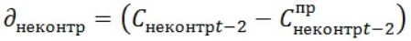

where:

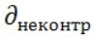

– adjustment for the change in unmanageable expenses.
The adjustment of profit based on implementation of the investment program is calculated using the formula:

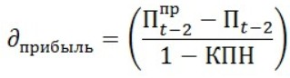

where:

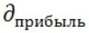

– the adjustment of profit with account of implementation of the investment program;

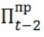

- the amount of the entity’s profit for year t-2 according to data approved by the department of the authorized body for the entity’s use for annual tariff adjustment, thousand tenge;
P_{t-2} - the amount of the entity’s profit for year t-2, determined by the department of the authorized body within the framework of monitoring the implementation of the investment program for the entity’s regulated service, thousand tenge.
88. After verifying the implementation of the entity’s investment program, the reporting data on the entity’s income, expenses and tariffs, as well as their compliance with quality standards within the framework of annual monitoring, the department of the authorized body sends a notification of annual monitoring results to the entity.
The data on the entity’s income, expenses and tariffs, as well as its compliance with quality standards, obtained by it from annual monitoring results, are used by the entity for the calculation of tariffs for years following a reporting year.
89. The entity applies the amended tariff for the regulated service from January 1 through December 31 of a year following a respective year.
Appendix 1 to the
Tariff Calculation Methodology
with account of stimulating tariff
setting methods
Form
Sectoral X-factors taken into account in tariffs for regulated services
of entities, by industries of natural monopolies
The validity period of sectoral Х-factor – the years _____-_____
№ | Industry | Sectoral Х-factor for each year of its validity period, in %
 |  | the year_____ | … | the year___
1 | 2 | 3 | 4 | 5
1 | Energy sector, which includes the following areas of natural monopolies:  electric power transmission;  production, transmission, distribution and (or) supply of heat energy, except for heat energy generated using geothermal heat, groundwater, rivers, reservoirs, waste water of industrial enterprises and power plants, sewage treatment plants;  technical dispatching of supply to the grid and consumption of electrical energy;  organization of balancing the production and consumption of electrical energy.
2 | Pipeline transport, which includes the following areas of natural monopolies:  transportation of oil and (or) oil products through trunk pipelines, except for their transportation for transit purposes through the territory of the Republic of Kazakhstan and export outside the Republic of Kazakhstan;  storage, transportation of commercial gas through connecting, main gas pipelines and (or) gas distribution systems, operation of group tank installations, as well as transportation of raw gas through connecting gas pipelines, except for storage and transportation of commercial gas for transit purposes through the territory of the Republic of Kazakhstan and export outside the Republic Kazakhstan.
3 | Railway transport, which includes the following areas of natural monopolies:  main railway networks, except for main railway network services for the carriage of goods in containers, the transport of empty containers and the transit carriage of goods through the territory of the Republic of Kazakhstan;  railway track services with railway transport facilities under concession agreements in the absence of a competitive railway track;  approach lines in case of no competitive approach line.
4 | Air transport, which includes the following areas of natural monopolies:  air navigation, except for air navigation services for international and transit flights;  airports, except for air transportation services, carrying out transit flights through the airspace of the Republic of Kazakhstan with technical landings at airports of the Republic of Kazakhstan for non-commercial purposes.
5 | Communication, which includes the following areas of natural monopolies:  Leasing or provision for use of cable channels.
6 | Water supply, which includes the following areas of natural monopolies:  water supply and (or) water disposal.
7. | Sea transport, which includes the following area of natural monopoly:  harbors.
Appendix 2 to the
Tariff Calculation Methodology
with account of stimulating tariff
setting methods
Form
Individual Х-factors taken into account in the formula of calculation of the tariff for the
regulated service ________________________________________________
(the regulated service) specifically for each entity
Validity period: the years_____________________
 |  | Х-factors of the entities
 |  | Area of natural monopoly
 |  | Name of a service
 |  | Total number of entities providing the service (excluding low power and newly created entities)
 |  | The number of entities whose data are used for analysis
 |  | Period under analysis:
 |  | Start
 |  | End
 |  | Structural parameters used to determine groups of similar entities and calculate individual X-factors:
1
2
3
…
n
№ | Group 1 |  |  | Group .. |  | Group ...
 | Entity name |  | Xind. об | Entity name | Xind. об | Entity name | Xind. об
1 | 2 |  | 3 | …
1
2
…
Note:
in the “Entity name” column one shall indicate names of entities from the list of similar entities providing the regulated service approved by the department of the authorized body, whose data are used to assess individual X-factors taken into account in the formula for calculating tariffs for this regulated service.
The head or his/her deputy
________________________________________________________________
(the last and first names, patronymic (if any)., signature)
Stamp here (if any).
The date "__" ____________20___
Appendix 3 to the
Tariff Calculation Methodology
with account of stimulating tariff
setting methods
Form
Information on historical (actual) and estimated expenses for the provision of a regulated service
________________________________________________________________
(the regulated service)
by an entity ____________________________________________________ (the entity applying for approval of the tariff)
№ | Indicator | Unit of measurement (thousand tenge) | The entity’s actual expenses for historical period |  |  | The amount of expenses declared by the entity
 |  |  | year 1 | … | Year Pdecl | year 1 | … | year Pdecl
1 | 2 | 3 | 5 | 6 | 7
I | Manageable expenses of the entity
1. | Production expenses, total, including
1.1. | Material expenses (excluding the purchase of strategic goods), total, including
1.1.1. | Raw and other materials
1.1.2. | Fuels and lubricants
1.1.3. | Fuel
1.1.4. | Energy
1.2. | Salary, including social tax
1.3. | Other (expand)
2. | General and administrative expenses, total, including
2.1. | Salary, including social tax
2.2. | Remuneration expenses
2.3. | Current and major repairs that do not increase the value of fixed assets
2.4. | Other (expand)
II | Unmanageable expenses of the entity
1. | Production expenses, total, including
1.1. | Material expenses for the purchase of strategic goods, total, including
1.1.1. | Raw and other materials
1.1.2. | Fuels and lubricants
1.1.3. | Fuel
1.1.4. | Energy
1.2. | Depreciation
2. | General and administrative expenses, total, including
2.1. | Depreciation
3. | Taxes and other obligatory payments and fees
4. | Normative technical losses
5 | Expenses for the payment of interest on borrowed funds, which are used to finance investment expenses
6. | Other investment expenses (expand)
III | Additional information
1. | Regulated involved asset base (RAB)
2. | The forecast volume of provision of the regulated service | Natural unit
The head or his/her deputy __________________________________________________
(the last and first names, patronymic (if any)., signature)
Stamp (if any)
Note:
The data in the “Indicator” column can be extended or supplemented, if necessary.
In the “Period of validity of the tariff for the regulated service (year 1, ..., Pdecl year)” column, one shall indicate the period of validity of the tariff for the regulated service declared by the entity.
In Section III “Investment expenses”, one shall indicate investment expenses, which sources of financing are own funds.
In Section IV “Profit”, in the “Regulated involved asset base - RAB)” column, one shall indicate the value of assets classified as involved in the provision of the regulated service in accordance with the procedure for maintaining separate accounting of income, expenses and involved assets for each type of regulated services (goods, works) and in general for another activity approved by the authorized body.
Historical (actual) expenses for five years preceding the date of the entity’s application and the entity’s estimated expenses for each year of the tariff validity period declared by the entity are formed by the entity in accordance with the Special Procedure, with no regard for indicators of socio-economic development of the Republic of Kazakhstan (inflation).
Appendix 4 to the
Tariff Calculation Methodology
with account of stimulating tariff
setting methods
Form
Minimal list of structural parameters used to assess individual X-factors for the following
regulated services
Transmission and (or) distribution of electrical energy in the field of transmission and (or) distribution of electrical energy.
Technical dispatching of supply to the network and consumption of electrical energy in the field of technical dispatch of supply to the network and consumption of electrical energy.
Organization of balancing of the production and consumption of electrical energy in the field of organization of balancing of the production and consumption of electrical energy.
Item № | Structural parameters | Unit of measurement
1. | Number of connected consumers (customers) | Thousand consumers
2. | The total length of the lines (only for regulated services for the transmission of electrical energy in the field of transmission of electrical energy) | Thousand kilometers
3. | The number of power transformers (only for regulated services for the transmission of electrical energy in the field of transmission of electrical energy) | Pieces
4. | Total capacity of power transformers (only for regulated services for the transmission of electrical energy in the field of transmission of electrical energy) | MW/hour
5. | Maximum load in networks recorded within a year (only for regulated services for the transmission of electrical energy in the field of transmission of electrical energy) | kV
6. | The volume of the regulated service provided over a year | Kilowatt/hour
7. | Service coverage area | Square kilometers
Note: if a structural parameter is not acceptable for the regulated service, such a structural parameter is not taken into account for such a regulated service.
The minimal list of structural parameters used to assess individual X-factors for such regulated services as:
transportation of commercial gas through connecting gas pipelines;
transportation of commercial gas through trunk pipelines;
transportation of commercial gas through gas distribution systems for consumers of the Republic of Kazakhstan;
transportation of liquefied gas through pipelines from the group tank installation to the consumer’s valve;
commercial gas storage;
transportation of raw gas through connecting gas pipelines.
Item № | Structural parameters | Unit of measurement
1. | Number of connected consumers (customers) | Thousand consumers
2. | The total length of gas pipelines | Thousand kilometers
3. | Total capacity of gas pipelines/gas distribution system | Thousand cubic meters
4. | Maximum pressure in gas pipelines/gas distribution systems | mPA
5. | The volume of the regulated service provided over a year | Thousand cubic meters
The minimal list of structural parameters used to assess individual X-factors for the following regulated services:
heat production;
transmission and distribution of heat energy;
heat energy supply;
production, transmission and distribution of heat energy;
production, transmission, distribution and (or) supply of heat energy.
Item № |  | Structural parameters | Unit of measurement
1. |  | Number of connected city facilities | Pieces
2. |  | Total length of pipelines | Thousand kilometers
3. |  | Heat output of a boiler | Gcal/hour (megawatt/hour)
4. |  | Pump power | Megawatt/hour
5. |  | Maximum network load | Thousand Gcal
6. |  | The volume of the regulated service provided over a year | Thousand Gcal
Note: if a structural parameter is not acceptable for the regulated service, such a structural parameter is not taken into account for such a regulated service.
The minimal list of structural parameters used to assess individual X-factors for the following regulated services:
water supply through pipelines;
water supply through distribution networks;
water supply through the channels;
regulation of surface runoff using retaining waterworks;
wastewater disposal;
wastewater treatment.
Item № | Structural parameters | Unit of measurement
1. | Number of connected consumers (customers) | Thousand consumers (subscribers)
2. | Total length of water supply networks | Thousand kilometers
3. | Power of the transformer group of pumping stations of lifts I, II and water treatment facilities | Megawatt/hour
4. | Total power of installed pumping equipment | Megawatt/hour
5. | Estimated pressure at water supply by the pumping station of lift II | м
6. | Actual head at water supply by pumping station of lift II | м
7. | The volume of the regulated service provided over a year | Thousand cubic meters
The minimal list of structural parameters used to assess individual X-factors for the following regulated services:
provision of the main railway network for use, except for the main railway network services for the carriage of goods in containers and the transport of empty containers;
organization of rolling stock passes along the main railway network, except for the main railway network services for the carriage of goods in containers and the transport of empty containers;
provision of the mainline railway network for use and organization of the passage of rolling stock along it, except for the mainline railway network services for the carriage of goods in containers, the transport of empty containers and the transit of goods through the territory of the Republic of Kazakhstan;
provision for use of railway lines with railway transport facilities under concession agreements in case of absence of a competitive railway line;
provision of approach lines for the passage of rolling stock in case of no competitive approach lines;
provision of an approach line for shunting, loading and unloading, other technical operations of the transportation process, as well as for parking of rolling stock unforeseen by technical operations of the transportation process in case of no competitive approach line.
Item № | Structural parameters | Unit of measurement
1. | Maximum permissible train weight | Ton
2. | Maximum allowable speed of passenger trains | Kilometer/hour
3. | Maximum allowable speed of freight trains | Kilometer/hour
4. | The volume of the regulated service rendered per year in the freight traffic | Т-kilometer
5. | The volume of the regulated service rendered per year in passenger traffic | Pass-kilometer
The minimal list of structural parameters used to assess individual X-factors for the following regulated services:
air navigation services for aircraft in the airspace of the Republic of Kazakhstan, except for air navigation services for aircraft engaged in international flights;
air navigation services for aircraft in the aerodrome area, except for air navigation services for aircraft engaged in international flights.
Item № | Structural parameters | Unit of measurement
1. | Number of airlines served | Pieces
2. | Number of aircraft/flights served per year | Pieces
3. | The volume of the regulated service provided over a year | Natural unit
The minimal list of structural parameters used to assess individual X-factors for the following regulated services:
services for the vessel’s entering a seaport for cargo operations and (or) other purposes, followed by departure from the port (ship call);
ensuring the take-off and landing of an aircraft, except for the service of air transportation, carrying out transit flights through the airspace of the Republic of Kazakhstan with technical landings at airports of the Republic of Kazakhstan for non-commercial purposes;
provision of aviation security, except for the service of air transportation, carrying out transit flights through the airspace of the Republic of Kazakhstan with technical landings at airports of the Republic Kazakhstan for non-commercial purposes;
provision of an aircraft parking space for more than three hours after landing for passenger certified types of aircraft and six hours for cargo and cargo-and-passenger certified types of aircraft if there is cargo (mail) to be processed (loaded and/or unloaded) at the airport of landing, except for the service of air transportation, carrying out transit flights through the airspace of the Republic of Kazakhstan with technical landings at airports of the Republic of Kazakhstan for non-commercial purposes;
provision of parking space for the aircraft at the base aerodrome.
Item № | Structural parameters | Unit of measurement
1. | Number of runways | pieces
2. | Maximum take-off run of the airfield available | kilometer
3. | Maximum number of passengers per day during the year | Passenger/day
4. | Number of flights serviced | Pieces
5. | The volume of the regulated service provided over a year | Natural unit
The minimal list of structural parameters used to assess individual X-factors for the following regulated services:
provision for use of telephone conduit.
Item № | Structural parameters | Unit of measurement
1. | Number of connected consumers (subscribers) | Thousand consumers
2. | Total pipeline length | Thousand kilometers
3. | Maximum power of pipelines | Natural unit
4. | Maximum network load during a year | Natural unit
5. | The volume of the regulated service provided over a year | Natural unit
The minimal list of structural parameters used to assess individual X-factors, the following regulated services:
unified routing operator activity;
oil pumping through the main pipeline system;
discharge of oil from railway tanks;
loading of oil into railway tanks;
loading of oil in a tanker;
discharge of oil from tank trucks;
loading of oil in tankers;
oil storage;
oil transshipment;
oil blending.
Item № | Structural parameters | Unit of measurement
1. | Number of service consumers | Thousand consumers
2. | Total length of pipelines | Thousand kilometers
3. | Average throughput at all sites | thousand t/day
4. | The volume of the regulated service provided over a year (freight turnover) | million t-kilometer
Appendix 5 to the
Tariff Calculation Methodology
with account of stimulating tariff
setting methods
Form
Structural parameters for use in assessing individual
X-factors taken into account in the formula for calculating
tariffs for this regulated service ________________________________________________________
(the regulated service)
The form is submitted to: _________________(the department of the authorized body)
Deadline for submission: ___________________
Purpose: assessment of individual Х-factors
Item № | The structural indicator | Unit of measurement | 1 year | 2 year | 3 year | 4 year | 5 year
1
2
3
Data on the entity:
Name of the entity ________________________________________________
BIN or IE

Address _________________________________________________________
Telephone _______________________________________________________
Email address ____________________________________________________
Last and first names, patronymic (if any) and telephone of the contact person
____________________________
I confirm the completeness and accuracy of the attached documents and information.
The head or his/her deputy
________________________________________________________________
(last and first names, patronymic (if any)., signature)
Stamp (if any).
The date "__" ____________20___
Note:
In “The structural parameter” column, the department indicates structural parameters from a draft preliminary list.
If the entity has proposals to add new structural parameters to the draft preliminary list, it adds new lines below the indicators of the draft preliminary list.
The “year 1” - “year 5” columns indicate the values of structural parameters for each year of a five-year period preceding the year, in which the department of the authorized body started the development of individual X-factors.
Appendix 6 to the
Tariff Calculation Methodology
with account of stimulating tariff
setting methods
Form
Significance of the use of structural parameters in determining groups of similar entities and
calculating individual X-factors
Area of natural monopoly
The service
Period under analysis:
Start
End
Name | Structural parameter 1 | Structural parameter … | Structural parameter S
1 | 2 | 3 | 4
Attribute of significance
Removal of structural parameters (0 – structural parameter was removed, if otherwise -1) | 1 | 1 | 1
Note:
In the “Attribute of significance” line, a structural parameter is indicated either as “significant” or “insignificant”.
Appendix 7 to the
Tariff Calculation Methodology
with account of stimulating tariff
setting methods
Form
The list of structural parameters used to assess individual X-factors taken into account in the
formula for calculating tariffs for this regulated service ________________________________________________________________
(the regulated service)
Item № | Structural parameter | Unit of measurement
1 | 2 | 3
2
3
…
Appendix 8 to the
Tariff Calculation Methodology
with account of stimulating tariff
setting methods
Form
The results of statistical analysis of similar entities
Conversion of manageable expenses into real terms by the consumer price index: in 20__ …%, in 20__ …%, in 20__ …%, in 20__ …%
1 group of similar entities
Area of natural monopoly
The service
The total number of entities providing the service (excluding low power and newly created entities)
The number of entities whose data are used for analysis
Period under analysis:
Start
End
Structural parameters used to determine groups of similar entities and calculate individual X-factors:
1
2
3
…
Year | Structural parameter 1 | Structural parameter 2 | Structural parameter 3 | … | Structural parameter |  | Manageable expenses in real terms, thousand tenge | The standardized ratio of the average value of estimated balances
Entity 1
Year 1
Year 2
Year 3
…
Year n
Entity 2
Year 1
…
…
Appendix 9 to the
Tariff Calculation Methodology
with account of stimulating tariff
setting methods
Form
The list of groups of similar entities providing a regulated service, whose data are used in
assessing individual X-factors
Return to title page
Area of natural monopoly
The service
Period under analysis:
Structural parameters used to determine groups of similar entities and calculate individual X-factors:
1
Item № | Group 1 | Group … | Group …
1 | 2 | … | …
Appendix 10 to the
Tariff Calculation Methodology
with account of stimulating tariff
setting methods
Form
Opinion on the results of calculation of estimated individual X-factors specifically for
each entity, which are included in the tariffs for the regulated service
________________________________________________________________
(the regulated service)
 | Entities’ Х – factors
 | Area of natural monopoly
 | The service
 | Total number of entities providing the service (excluding low power and newly created entities)
 | The number of entities, whose data are used for analysis
 | Period under analysis:
 | Start
 | End
 | Structural parameters used to determine groups of similar entities and calculate individual X- factors:
1
2
3
…
n
Item № | Group 1 |  | Group ... |  | Group ...
 | Entities’ names | Xind. об | Entities’ names | Xind. об | Entities’ names | Xind. об
1 | 2 | 3 | …
1
2
…
Appendix 11 to the
Tariff Calculation Methodology
with account of stimulating tariff
setting methods
Form 1
The list of the entity’s statistically unreliable expenses
________________________________________________________________
(the entity’s name)
for the provision of a regulated service
_______________________________________________________________
(the regulated service)
broken down by expense items  Item № | The item of expenses, the amount of which, declared by the entity, is recognized as statistically unreliable | Unit of measurement | Amount of expenses declared by the entity
Year 1 |  |  | … | Year Pdecl
1 | 2 | 3 | 5 | …
 |  | Thousand tenge
Note:
In the “year 1” – “year P^{decl}” columns, one indicates the data for the period of validity of the tariff for the regulated service declared by the entity. In this case, the cell in which the amount of expenses, declared by the entity, in year t, which is recognized as statistically unreliable, is marked red (red fill).
Form 2
The calculation carried out within the framework of statistical analysis of reliability of the
entity’s expenses ______________________________________________
(the entity’s name)
for the provision of a regulated service
____________________________________________________
(the regulated service)
 |  |  | Report on reliability of declared expenses
 | Area of natural monopoly
 | The service
 | The entity’s name
Item № | Name | Unit of measurement | Year 1 | … | Year Т | … | Lower reliability limit | Upper reliability limit | Year 1 | … | Year T
1 | 2 | 3 | 4 | 5 | 6 | 7 | 8 | 9 | 10 | 11 | 12
I | Manageable expenses of the entity | Thousand tenge
1 | Production expenses, total, including * | Тысяч тенге
1.1 | Material expenses (excluding the purchase of strategic goods), total, including | Thousand tenge
1.2 | Labor expenses, total | Thousand tenge
1.3 | Repairs, total | Thousand tenge
1.4 | Other expenses, total | Thousand tenge
2 | General and administrative expenses ** | Thousand tenge
2.1 | Administrative expenses, total | Thousand tenge
2.2 | Distribution expenses, total | Thousand tenge
II | Unmanageable expenses of the entity | Thousand tenge
1 | Production expenses, total, including | Thousand tenge
1.1 | Material expenses for the purchase of strategic goods, total, including | Thousand tenge
1.2 | Depreciation | Thousand tenge
1.3 | Taxes and other obligatory payments and fees | Thousand tenge
2 | General and administrative expenses, total, including | Thousand tenge
2.1 | Depreciation | Thousand tenge
2.2 | Taxes and other obligatory payments and fees | Thousand tenge
2.3 | Normative technical losses | Thousand tenge
 | Total amount of expenses | Thousand tenge
Note:
For each item k and year t in the “Reliability of expenses declared by the entity for each year broken down by expense items” box, it is indicated:
“NO” - the amount of expense item k for year t declared by the entity is not statistically reliable if its value is higher than the upper quartile or less than the lower quartile in year t;
“YES” - the amount of expense item k for year t declared by the entity is statistically reliable if its value is less than or equal to the upper quartile or less or equal to the lower quartile.
Form 3
Results of consideration by the Working Group of reliability of expenses declared by
the entity
Item № | The expense items, the amount declared by the entity, which was recognized unreliable pursuant to the results of statistical analysis | The amount of expenses, declared by the entity, that was recognized as unreliable pursuant to the results of statistical analysis, for each year of the validity period of the declared tariff, in thousand tenge |  |  | The amount of expenses recognized as reliable by the Working Group pursuant to the results of statistical analysis, for each year of the validity period of the declared tariff
 |  | year 1 | … | year Pdecl | year 1 | … | Year Pdecl
Appendix 12 to the
Tariff Calculation Methodology
with account of stimulating tariff
setting methods
Form
Report on income, expenses and tariffs
Item № | Name | Unit of measurement | Period of regulation
 |  |  | 1 year |  |  | 2 year |  |  | 3 year |  |  | 4 year |  |  | 5 year
 |  |  | Plan* | Fact** | Deviation in % | Plan* | Fact** | Deviation in % | Plan* | Fact** | Deviation in % | Plan* | Fact** | Deviation in % | Plan* | Fact** | Deviation in %
I | Manageable expenses of the entity | Thousand tenge
II | Adjusted for inflation, X-factors  manageable expenses | Thousand tenge
1 | Adjustment index for manageable expenses
1.1 | Estimated inflation
1.2 | Sectoral Х-factor
1.3 | Individual Х-factor
1.4 | Actual inflation
III | Adjustment for actual inflation | Thousand tenge
IV | Unmanageable expenses of the entity | Thousand tenge
2 | Production expenses, total, including | Thousand tenge
2.1 | Material expenses for the purchase of strategic goods, total, including | Thousand tenge
2.1.1 | Purchased water | Thousand tenge
2.1.2 | Purchased electrical energy | Thousand tenge
2.2 | Depreciation | Thousand tenge
2.3 | Taxes | Thousand tenge
 | Tax payments | Thousand tenge
2.3.2 | Compulsory types of insurance | Thousand tenge
3 | General and administrative expenses, total, including | Thousand tenge
3.1 | Depreciation | Thousand tenge
3.2 | Taxes | Thousand tenge
3.2.1 | Tax payments | Thousand tenge
3.2.2 | Compulsory types of insurance | Thousand tenge
V | Actual unmanageable expenses of the entity | Thousand tenge
4 | Production expenses, total, including | Thousand tenge
4.1 | Material expenses for the purchase of strategic goods, total, including | Thousand tenge
4.1.1 | Purchased water | Thousand tenge
4.1.2 | Purchased electrical energy | Thousand tenge
4.2 | Depreciation | Thousand tenge
4.3 | Taxes | Thousand tenge
4.3.1 | Tax payments | Thousand tenge
4.3.2 | Compulsory types of insurance | Thousand tenge
5 | General and administrative expenses, total, including | Thousand tenge
5.1 | Depreciation | Thousand tenge
5.2 | Taxes | Thousand tenge
5.2.1 | Tax payments | Thousand tenge
5.2.2 | Compulsory types of insurance | Thousand tenge
VI | Adjustment with account actual unmanageable expenses | Thousand tenge
VII | Total amount of expenses(II+III+IV+VI) | Thousand tenge
VIII | Profit for the approved investment program/(1-CIT) | Thousand tenge
IX | Profit for actual expenses of the investment program/(1-CIT) | Thousand tenge
6.1 | Actual expenses of the investment program
6.2 | Actual borrowed funds
6.3 | Actual budget funds
6.4 | Depreciation
X | Adjustment of the profit amount with account of implementation of investment program
XI | Adjustment with account of actual volume
7 | Actual volume of services provided
XII | Bonus/penalty for compliance with service quality standards
8.1 | The coefficient of compliance with service quality standards
8.2 | Actual income
XIII | Income VII+VIII+X+XI+XII-10 | Thousand tenge
9 | Volume of services | Thousand cubic meters
10 | Income earned unreasonably | Thousand tenge
XIV | Average tariff (XIII/9) | Tenge/cubic meters
XV | Tariff increase compared to the previous year
11 | Volume of services (1 group of consumers) | Thousand cubic meters
12 | Volume of services (2 group of consumers) | Thousand cubic meters
13 | Volume of services (3 group of consumers) | Thousand cubic meters
14 | Tariff for 1 group of consumers | Tenge/cubic meters
15 | Tariff increase compared to the previous year
16 | Tariff for 2 group of consumers | Tenge/cubic meters
17 | Tariff increase compared to the previous year
18 | Tariff for 3 group of consumers | Tenge/cubic meters
19 | Tariff increase compared to the previous year
Note:
*– Provided for in the approved tariff estimates
**– Actual indicators of tariff estimates

© 2012. «Institute of legislation and legal information of the Republic of Kazakhstan» of the Ministry of Justice of the Republic of Kazakhstan

