

**On approval of the natural norms of provision with uniform (without shoulder straps) of employees of the economic investigation service of the financial monitoring bodies of the Republic of Kazakhstan**

***Invalidated***
***Unofficial translation***

Order of the First Deputy of the Prime Minister of the Republic of Kazakhstan – Minister of Finance of the Republic of Kazakhstan dated April 4, 2019 no. 297. Registered with the Ministry of Justice of the Republic of Kazakhstan on April 9, 2019 no. 18485. Abolished by Order of the Chairman of the Financial Monitoring Agency of the Republic of Kazakhstan dated April 29, 2022 No. 24

*Unofficial translation*

      Footnote. Abolished by Order of the Chairman of the Financial Monitoring Agency of the Republic of Kazakhstan dated April 29, 2022 No. 24 (effective ten calendar days after the date of its first official publication).

      In accordance with clause 2 of article 69 of the Budget Code of the Republic of Kazakhstan dated December 4, 2008 **I HEREBY** **ORDER**:

      1. to approve the attached natural norms of provision with uniform (without shoulder straps) of employees of the economic investigation service of the financial monitoring bodies of the Republic of Kazakhstan.

      2. To declare to be no longer in force the Order of the Minister of Finance of the Republic of Kazakhstan dated May 19, 2015 no. 307 "On approval of the natural norm of provision with uniform (without shoulder straps) of employees of the economic investigation service of the state revenue bodies of the Republic of Kazakhstan (registered with the Register of State Registration of Normative Legal Acts under no. 11275, published on June 23, 2015 in "Adilet" Information Legal System).

      3. The Department of Internal Procurement and Assets of the Ministry (Kalas Ye.S.), in accordance with the procedure, established by the law, shall ensure:

      1) state registration of this order with the Ministry of Justice of the Republic of Kazakhstan;

      2) within ten calendar days from the date of state registration of this order direction of it in the Kazakh and Russian languages to the Republican State Enterprise on the Right of Economic Management "Republican Center of Legal Information" of the Ministry of Justice of the Republic of Kazakhstan for official publication and inclusion to the Reference Control Bank of Normative Legal Acts of the Republic of Kazakhstan;

      3) placement of this order on the Internet resource of the Ministry of Finance of the Republic of Kazakhstan;

      4) within ten working days after the state registration of this order in the Ministry of Justice of the Republic of Kazakhstan, submission to the Department of Legal Services of the Ministry of Finance of the Republic of Kazakhstan information on the implementation of measures provided for in subclauses 1), 2) and 3) of this clause.

      4. This order shall come into force upon expiry of ten calendar days after the day its first official publication.

|  |  |
| --- | --- |
| *First Deputy of the Prime Minister*  *of the Republic of Kazakhstan – Minister of Finance*  *of the Republic of Kazakhstan* | *А. Smailov* |

|  |  |
| --- | --- |
|  | Approved by the orde r of First Deputyof the Prime Minister of the Republic of Kazakhstan - Minister of Finance of the Republic of Kazakhstan dated April 4, 2019 no. 297 |

**Natural norms of provision with uniform (without shoulder straps) of employees of the economic**   
**investigation service of financial monitoring bodies of the Republic of Kazakhstan**

      Footnote. Natural norms – are in the wording of the order of the Minister of Finance of the Republic of Kazakhstan dated August 27, 2020 No. 788 (shall be enforced upon expiry of ten calendar days after its first official publication).

|  |  |  |  |  |  |
| --- | --- | --- | --- | --- | --- |
| № | Name of items | Unit of measurement | Number of items per one employee | Duration of wearing (in months) | Note |
| 1. Formal and casual uniforms (without shoulder straps) * | | | | | |
| 1. | Service cap | Piece | 1 | 24 |  |
| 2. | Fur cap with earflaps | Piece | 1 | 36 |  |
| 3. | Warm jacket | Piece | 1 | 36 |  |
| 4. | Neckscarf | Piece | 1 | 36 |  |
| 5. | Tunic with trousers | Set | 1 | 24 |  |
| 6. | Tunic with a skirt | Set | 1 | 24 |  |
| 7. | Men's trousers | Piece | 2 | 24 |  |
| 8. | Skirt | Piece | 1 | 24 |  |
| 9. | Women's trousers | Piece | 1 | 24 |  |
| 10. | White shirt with long sleeves | Piece | 2 | 24 |  |
| 11. | Blue or light blue shirt with short sleeve | Piece | 2 | 12 |  |
| 12. | Blue or light blue shirt with long sleeve | Piece | 2 | 18 |  |
| 13. | Men ankle boots | Pair | 1 | 24 |  |
| 14. | Women boots | Pair | 1 | 24 |  |
| 15. | Men shoes | Pair | 1 | 12 |  |
| 16. | Women shoes | Pair | 1 | 12 |  |
| 17. | Tie | Piece | 1 | 24 |  |
| 18. | Belt | Piece | 1 | 24 |  |
| 19. | Casual jacket | Piece | 1 | 24 |  |
| 2. Field uniform (without shoulder straps) * | | | | | |
| 20. | Field uniform | Set | 1 | 24 |  |
| 21. | Combat boots | Pair | 1 | 24 |  |
| 22. | T-shirt | Piece | 1 | 12 |  |

      Note:

      *samples of uniforms (without shoulder straps) and distinctive insignia are given in the Annex to these Norms.

      1. Wearing a uniform shall be mandatory while performing official duties.

      2. Duration of wearing uniforms and their elements shall be calculated from the date of issue.

      3. The provision with uniform shall be carried out at the expense of the authorized body, carrying out the functions of preventing, detecting, suppressing, disclosing and investigating economic and financial crimes and offenses.

      4. A parade uniform shall be a white shirt with a tunic, casual - a blue or light blue shirt with a tunic, a blue or light blue shirt with a jacket.

      5. Wearing field uniform shall be carried out by employees of the economic investigation service of financial monitoring bodies of the Republic of Kazakhstan, performing their duties in duty units and working with service dogs.

|  |  |
| --- | --- |
|  | Annex  to the Natural norms  of provision with uniform (without shoulder straps) of employees of the economic investigation service of financial  monitoring bodies of the Republic of Kazakhstan |

**Samples of uniform (without shoulder straps) of employees of the economic investigation**   
**of financial monitoring bodies of the Republic of Kazakhstan (hereinafter – the uniform)**

      1. A set of men's summer uniform includes (Picture 1 and 2):

      1) a dark blue service cap;

      2) a dark blue tunic;

      3) a dark blue casual jacket;

      4) dark blue trousers (2 pcs.);

      5) a white shirt with long sleeve;

      6) a blue or light blue shirt with short sleeve;

      7) a blue or light blue shirt with long sleeve;

      8) a blue tie;

      9) black shoes;

      10) a black belt.

      Picture 1 (men’s uniform)

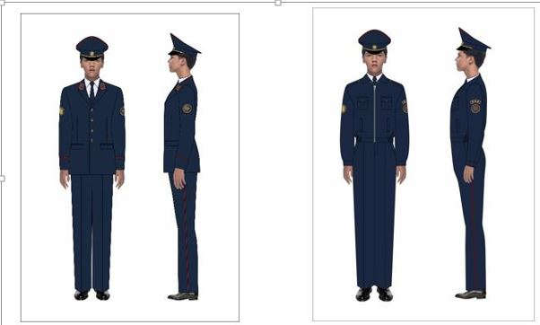

      a tunic                                                a jacket

      Picture 2 (men’s uniform)

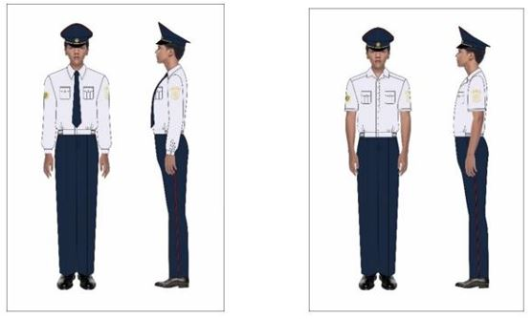

      a shirt with long sleeve                        a shirt with short sleeve

      2. A set of women's summer uniform includes (Picture 3 and 4):

      1) a dark blue service cap;

      2) a dark blue tunic;

      3) a dark blue casual jacket;

      3) casual jacket in dark blue;

      4) a dark blue skirt;

      5) dark blue trousers;

      6) a white shirt with long sleeves;

      7) a blue or light blue shirt with short sleeves;

      8) a blue or light blue shirt with long sleeves;

      9) a blue tie;

      10) black shoes.

      3 (women’s uniform)

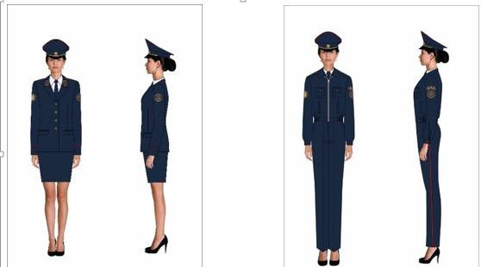

      a tunic with skirt                              a jacket with trousers

      Picture 4 (women’s uniform)

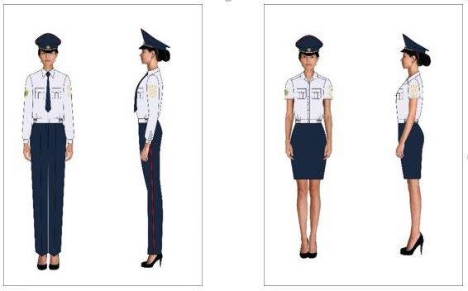

      a shirt with long sleeve                        a shirt with short sleeve

      3. A set of men's and women's winter uniforms includes (Picture 5):

      1) warm dark blue jacket;

      2) a dark blue fur cap with earflaps;

      3) a dark blue neckscarf;

      4) warm black ankle boots;

      5) warm women's black boots.

      Picture 5

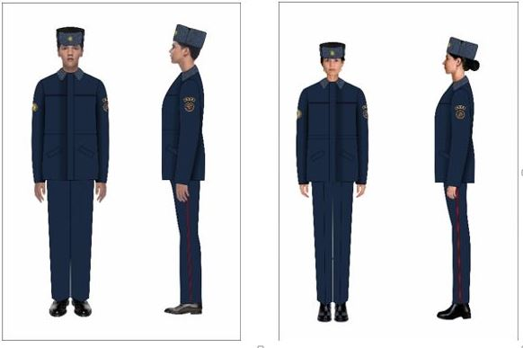

      A sample of field uniform for employees of the economic investigation service of financial monitoring bodies of the Republic of Kazakhstan

      4. A set of field uniform for men and women includes (Picture 6):

      1) a dark blue camouflage jacket;

      2) dark blue camouflage trousers;

      3) dark blue camouflage caps;

      4) a dark blue camouflage T-shirt;

      5) black combat boots.

      Picture 6

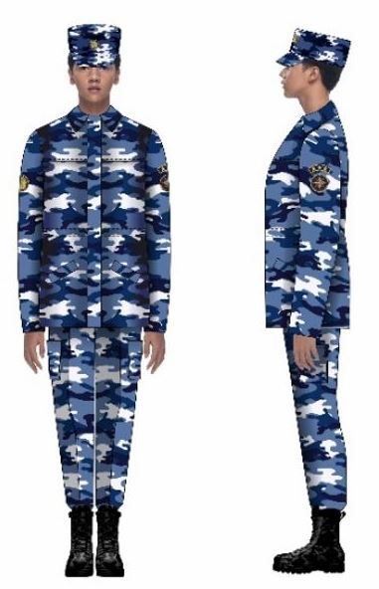

      Distinctive insignia

      5. Insignia of belonging to a law enforcement body within the Ministry of Finance of the Republic of Kazakhstan of employees shall be chevrons, insignia - buttonholes and sleeve insignia.

      Samples and descriptions of insignia of uniform (without shoulder straps) of employees of the economic investigation service of financial monitoring bodies:

      1) a chevron with signs of belonging to the Committee for financial monitoring of the Ministry of Finance of the Republic of Kazakhstan – of round shape, with yellow and dark red edging, in the center of the chevron on a dark blue (light blue, blue, or white) background there is an Emblem of the Republic of Kazakhstan in yellow colors. Along the outer circumference above the Emblem there is an inscription in the state language "Qazaqstan Respýblıkasy Qarjy mınıstrligi" in yellow, below "Qarjy monıtorıngi komıteti" (Picture 7).

      Placed on the right sleeve of the uniform (jacket, shirt).

      Picture 7

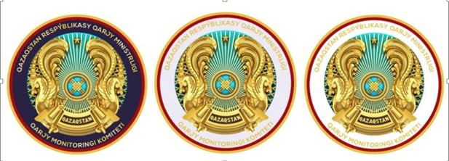

      2) a chevron with insignia of belonging to a law enforcement body – of round shape, with yellow and dark red edging, in the center of the chevron on a dark blue (blue or light blue or white) background there is a yellow logo of the body. Along the outer circumference under the logo there is an inscription in the state language "Ekonomıkalyq tergeý qyzmeti" in yellow (Picture 8).

      Placed on the left sleeve of the uniform (jacket, shirt).

      Picture 8



      3) sleeve insignia (for shirts and jackets) with designations of the qualification class - rounded, dark blue (blue or light blue or white) shall be placed above the chevron specified in subparagraph 2).

      On the sleeve insignia of the senior commanding staff there are large yellow stars (Picture 9):

      Qualifying Class 1 category - 3 stars;

      Qualifying Class 2 category - 2 stars;

      qualification class 3 category - 1 star.

      Picture 9

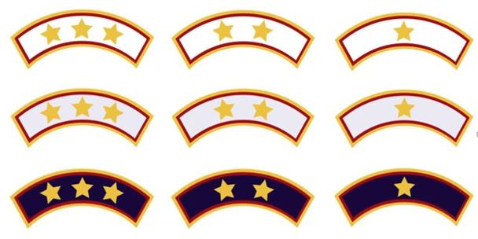

      qualification class of 1category      qualification class of 2 category      qualification class of 3category

      On the sleeve insignia of the middle commanding staff there are small yellow stars (Picture 10):

      qualification class of 4category - 4 stars;

      qualification class of 5category - 3 stars;

      qualification class of 6 category - 2 stars.

      Picture 10

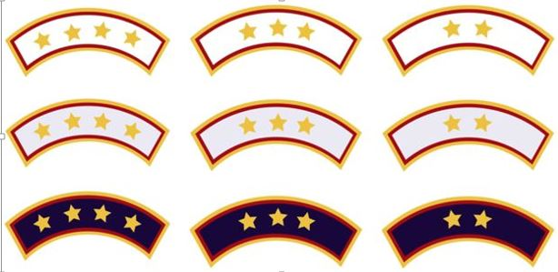

      4) insignia on the collars of the uniform (buttonholes) - trapezoidal, dark blue.

      On the buttonhole of the senior commanding staff, the stars are yellow and under the stars there are two dark red lines (Picture 11):

      qualification class of 1 category - 3 stars;

      category 2 qualification class - 2 stars;

      qualification class 3 categories - 1 star.

      Picture 11



      qualification class of 1category      qualification class of 2 category       qualification class of 3category

      On the buttonhole of the middle commanding staff, the stars are yellow and under the stars there is one dark red line (Picture 12):

      qualification class of 4 category - 4 stars;

      qualification class of 5 category - 3 stars;

      qualification class of 6category - 2 stars.

      Picture 12



      qualification class of 4th category       qualification class of 5th category       qualification class of 6th category

© 2012. «Institute of legislation and legal information of the Republic of Kazakhstan» of the Ministry of Justice of the Republic of Kazakhstan